Table 1
Connections over 200 kbps in at Least One Direction 2009-2013
(In thousands)

 | 2009 | 2010 |  | 2011 |  | 2012 |  | 2013
Technology | Dec | Jun | Dec | Jun | Dec | Jun | Dec | Jun | Dec
Total | 136,294 | 157,017 | 182,065 | 206,131 | 230,201 | 243,359 | 262,564 | 284,692 | 293,397
Total Fixed | 79,994 | 81,764 | 84,521 | 86,575 | 88,317 | 89,945 | 92,511 | 93,986 | 96,032
Mobile Wireless | 56,300 | 75,253 | 97,544 | 119,556 | 141,883 | 153,414 | 170,053 | 190,706 | 197,365

Table 2
Connections at Least 3 Mbps Downstream and 768 kbps Upstream 2009-2013
(In thousands)

 | 2009 | 2010 |  | 2011 |  | 2012 |  | 2013
Technology | Dec | Jun | Dec | Jun | Dec | Jun | Dec | Jun | Dec
Total | 40,669 | 45,552 | 55,110 | 64,819 | 82,015 | 100,268 | 129,398 | 165,110 | 211,218
Total Fixed | 38,963 | 41,364 | 44,694 | 48,577 | 51,097 | 57,243 | 64,657 | 68,673 | 78,175
Mobile Wireless | 1,706 | 4,188 | 10,416 | 16,242 | 30,918 | 43,025 | 64,741 | 96,437 | 133,043

Table 3
Residential Connections over 200 kbps in at Least One Direction 2009-2013
(In thousands)

 | 2009 | 2010 |  | 2011 |  | 2012 |  | 2013
Technology | Dec | Jun | Dec | Jun | Dec | Jun | Dec | Jun | Dec
Total | 117,089 | 132,567 | 149,441 | 171,773 | 186,516 | 196,665 | 215,817 | 235,273 | 246,797
Total Fixed | 73,394 | 75,251 | 76,918 | 78,906 | 80,706 | 82,217 | 84,392 | 85,277 | 87,599
Mobile Wireless | 43,695 | 57,316 | 72,523 | 92,867 | 105,810 | 114,448 | 131,425 | 149,996 | 159,197

Table 4
Residential Connections at Least 3 Mbps Downstream and 768 kbps Upstream 2009-2013
(In thousands)

 | 2009 | 2010 |  | 2011 |  | 2012 |  | 2013
Technology | Dec | Jun | Dec | Jun | Dec | Jun | Dec | Jun | Dec
Total | 38,426 | 42,243 | 47,632 | 51,783 | 63,736 | 78,609 | 105,749 | 137,792 | 179,840
Total Fixed | 36,844 | 39,037 | 41,769 | 45,263 | 47,427 | 53,070 | 59,914 | 63,342 | 72,476
Mobile Wireless | 1,582 | 3,206 | 5,863 | 6,520 | 16,309 | 25,539 | 45,835 | 74,450 | 107,364

Note: Some historical data have been revised. Figures may not sum to totals due to rounding.
Source: FCC Form 477, Parts I and VI.

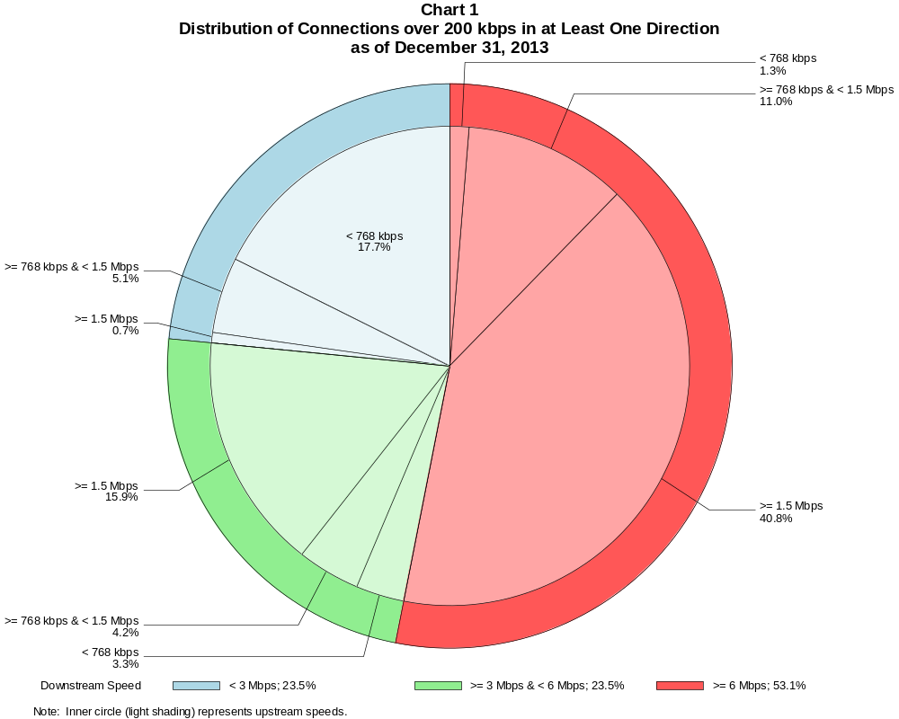

Connections over 200 kbps in at Least One Direction (in thousands)

 | Downstream Speed
Upstream Speed | Less than 3 Mbps | At least 3 Mbps  and less than 6 Mbps | At least 6 Mbps | Total
Less than 768 kbps | 51,794 | 9,590 | 3,754 | 65,138
At least 768 kbps & Less than 1.5 Mbps | 14,981 | 12,463 | 32,258 | 59,703
At least 1.5 Mbps | 2,060 | 46,761 | 119,735 | 168,556
Total | 68,836 | 68,815 | 155,746 | 293,397

Percentages

Less than 768 kbps | 17.7 | 3.3 | 1.3 | 22.2
At least 768 kbps & Less than 1.5 Mbps | 5.1 | 4.2 | 11.0 | 20.3
At least 1.5 Mbps | 0.7 | 15.9 | 40.8 | 57.4
Total | 23.5 | 23.5 | 53.1 | 100.0

Note: Figures may not sum to totals due to rounding.
Source: FCC Form 477, Part I.

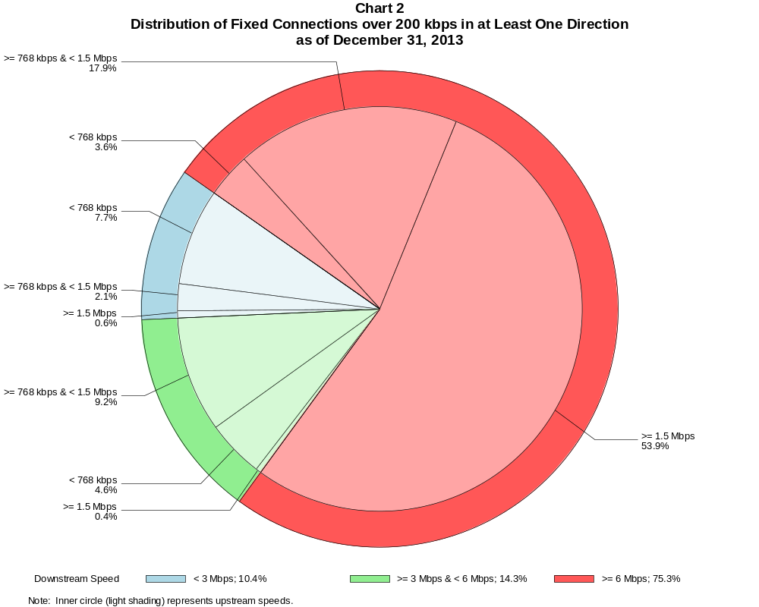

Fixed Connections over 200 kbps in at Least One Direction (in thousands)

 | Downstream Speed
Upstream Speed | Less than 3 Mbps | At least 3 Mbps  and less than 6 Mbps | At least 6 Mbps | Total
Less than 768 kbps | 7,413 | 4,409 | 3,420 | 15,242
At least 768 kbps & Less than 1.5 Mbps | 2,064 | 8,863 | 17,161 | 28,088
At least 1.5 Mbps | 552 | 415 | 51,736 | 52,703
Total | 10,029 | 13,686 | 72,317 | 96,032

Percentages

Less than 768 kbps | 7.7 | 4.6 | 3.6 | 15.9
At least 768 kbps & Less than 1.5 Mbps | 2.1 | 9.2 | 17.9 | 29.2
At least 1.5 Mbps | 0.6 | 0.4 | 53.9 | 54.9
Total | 10.4 | 14.3 | 75.3 | 100.0

Note: Figures may not sum to totals due to rounding.
Source: FCC Form 477, Part I.

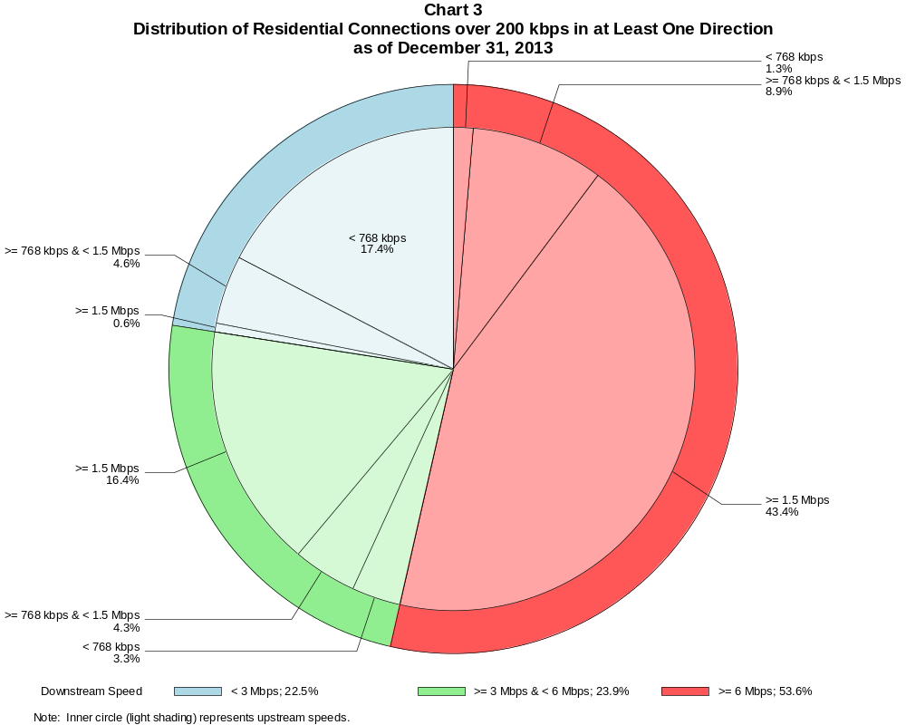

Residential Connections over 200 kbps in at Least One Direction (in thousands)

 | Downstream Speed
Upstream Speed | Less than 3 Mbps | At least 3 Mbps  and less than 6 Mbps | At least 6 Mbps | Total
Less than 768 kbps | 42,886 | 8,086 | 3,239 | 54,211
At least 768 kbps & Less than 1.5 Mbps | 11,299 | 10,554 | 21,941 | 43,794
At least 1.5 Mbps | 1,446 | 40,353 | 106,992 | 148,791
Total | 55,631 | 58,993 | 132,172 | 246,797

Percentages

Less than 768 kbps | 17.4 | 3.3 | 1.3 | 22.0
At least 768 kbps & Less than 1.5 Mbps | 4.6 | 4.3 | 8.9 | 17.7
At least 1.5 Mbps | 0.6 | 16.4 | 43.4 | 60.3
Total | 22.5 | 23.9 | 53.6 | 100.0

Note: Figures may not sum to totals due to rounding.
Source: FCC Form 477, Parts I and VI.

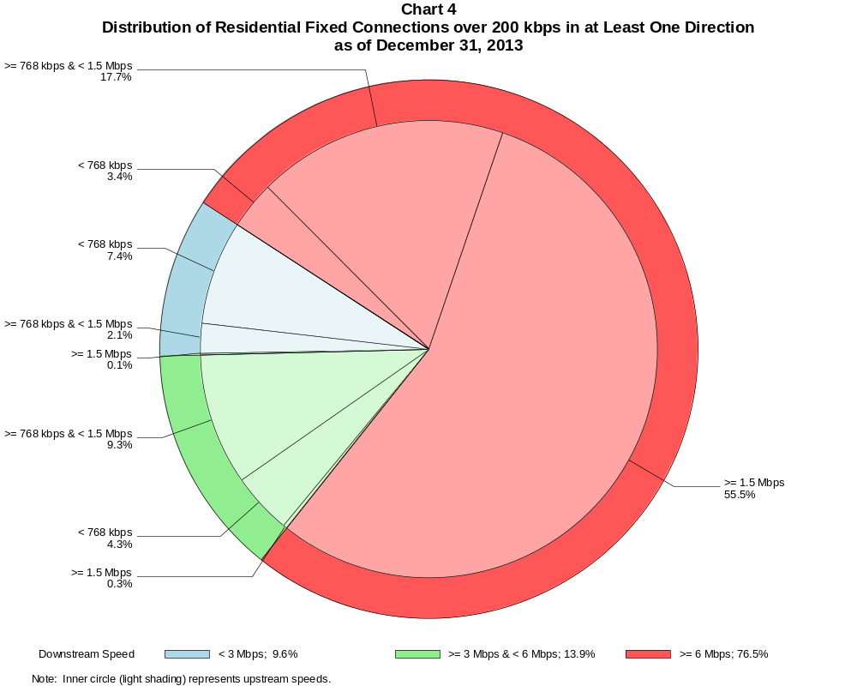

Residential Fixed Connections over 200 kbps in at Least One Direction (in thousands)

 | Downstream Speed
Upstream Speed | Less than 3 Mbps | At least 3 Mbps  and less than 6 Mbps | At least 6 Mbps | Total
Less than 768 kbps | 6,445 | 3,784 | 2,946 | 13,175
At least 768 kbps & Less than 1.5 Mbps | 1,846 | 8,142 | 15,509 | 25,497
At least 1.5 Mbps | 101 | 244 | 48,581 | 48,926
Total | 8,393 | 12,170 | 67,036 | 87,599

Percentages

Less than 768 kbps | 7.4 | 4.3 | 3.4 | 15.0
At least 768 kbps & Less than 1.5 Mbps | 2.1 | 9.3 | 17.7 | 29.1
At least 1.5 Mbps | 0.1 | 0.3 | 55.5 | 55.9
Total | 9.6 | 13.9 | 76.5 | 100.0

Note: Figures may not sum to totals due to rounding.
Source: FCC Form 477, Part VI.

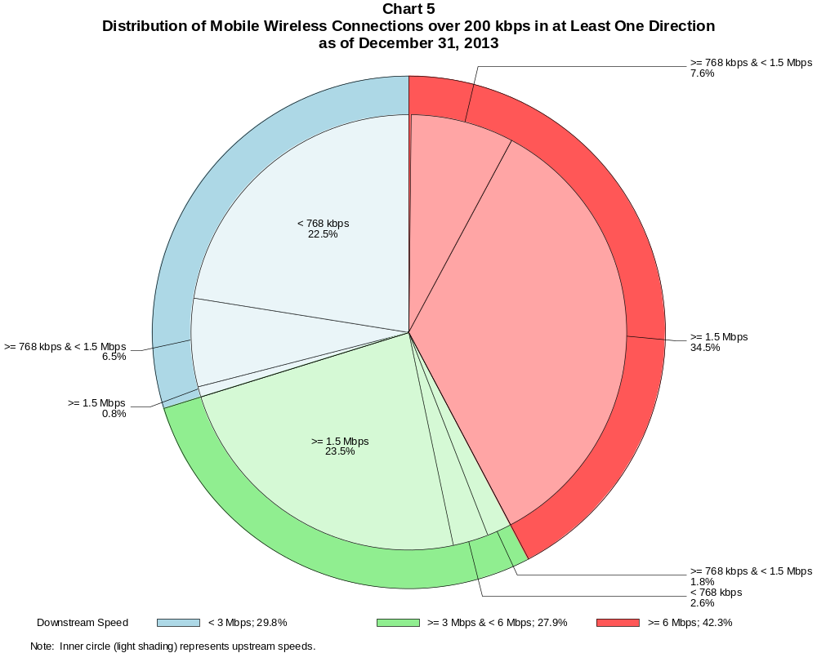

Mobile Wireless Connections over 200 kbps in at Least One Direction (in thousands)

 | Downstream Speed
Upstream Speed | Less than 3 Mbps | At least 3 Mbps  and less than 6 Mbps | At least 6 Mbps | Total
Less than 768 kbps | 44,381 | 5,181 | 334 | 49,896
At least 768 kbps & Less than 1.5 Mbps | 12,918 | 3,601 | 15,097 | 31,615
At least 1.5 Mbps | 1,508 | 46,346 | 67,999 | 115,853
Total | 58,807 | 55,128 | 83,430 | 197,365

Percentages

Less than 768 kbps | 22.5 | 2.6 | 0.2 | 25.3
At least 768 kbps & Less than 1.5 Mbps | 6.5 | 1.8 | 7.6 | 16.0
At least 1.5 Mbps | 0.8 | 23.5 | 34.5 | 58.7
Total | 29.8 | 27.9 | 42.3 | 100.0

Note: Figures may not sum to totals due to rounding.
Source: FCC Form 477, Part I.

Table 5
Connections over 200 kbps in at Least One Direction by Technology 2009-2013
(In thousands)

 | 2009 | 2010 |  | 2011 |  | 2012 |  | 2013
Technology | Dec | Jun | Dec | Jun | Dec | Jun | Dec | Jun | Dec
Total | 136,294 | 157,017 | 182,065 | 206,131 | 230,201 | 243,359 | 262,564 | 284,692 | 293,397
Total Fixed | 79,994 | 81,764 | 84,521 | 86,575 | 88,317 | 89,945 | 92,511 | 93,986 | 96,032
aDSL | 30,987 | 30,759 | 31,470 | 31,611 | 31,330 | 31,173 | 30,974 | 30,657 | 30,690
sDSL | 225 | 191 | 167 | 159 | 148 | 139 | 132 | 117 | 108
Other Wireline¹ | 719 | 755 | 795 | 778 | 795 | 770 | 796 | 769 | 772
Cable Modem | 42,439 | 43,923 | 45,334 | 46,698 | 48,263 | 49,664 | 51,646 | 52,760 | 54,009
FTTP² | 3,980 | 4,441 | 4,993 | 5,477 | 5,898 | 6,300 | 6,733 | 7,250 | 7,745
Satellite | 1,116 | 1,144 | 1,176 | 1,204 | 1,190 | 1,217 | 1,454 | 1,623 | 1,849
Fixed Wireless | 527 | 551 | 587 | 649 | 693 | 682 | 777 | 810 | 858
Mobile Wireless³ | 56,300 | 75,253 | 97,544 | 119,556 | 141,883 | 153,414 | 170,053 | 190,706 | 197,365

¹ Power Line and Other are summarized with Other Wireline to maintain firm confidentiality. No Power Line connections were reported after 2012. See Technical
Notes at the end of the report for a description of Form 477 technology categories and other reporting requirements.
² Fiber to the premises.

Note: Some historical data have been revised. Figures may not sum to totals due to rounding.
Source: FCC Form 477, Part I.

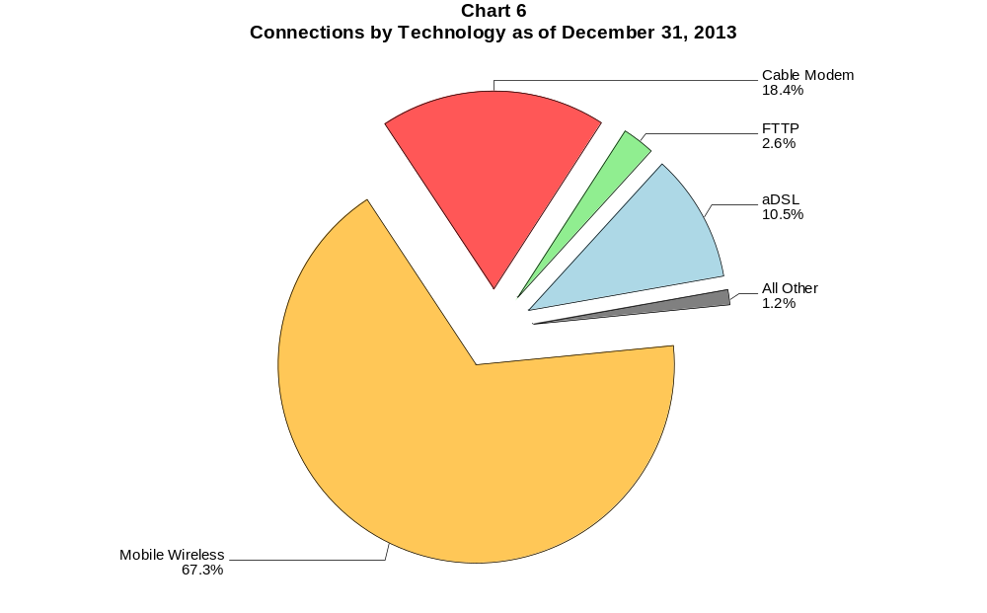

Table 6
Residential Connections over 200 kbps in at Least One Direction by Technology 2009-2013
(In thousands)

 | 2009 | 2010 |  | 2011 |  | 2012 |  | 2013
Technology | Dec | Jun | Dec | Jun | Dec | Jun | Dec | Jun | Dec
Total | 117,089 | 132,567 | 149,441 | 171,773 | 186,516 | 196,665 | 215,817 | 235,273 | 246,797
Total Fixed | 73,394 | 75,251 | 76,918 | 78,906 | 80,706 | 82,217 | 84,392 | 85,277 | 87,599
aDSL | 27,402 | 27,488 | 27,467 | 27,754 | 27,758 | 27,632 | 27,391 | 26,869 | 27,248
sDSL | 85 | 65 | 53 | 52 | 54 | 49 | 50 | 43 | 39
Other Wireline¹ | 56 | 61 | 76 | 45 | 40 | 14 | 34 | 22 | 22
Cable Modem | 40,872 | 42,178 | 43,295 | 44,480 | 45,832 | 47,033 | 48,716 | 49,494 | 50,709
FTTP² | 3,758 | 4,185 | 4,704 | 5,118 | 5,521 | 5,892 | 6,270 | 6,732 | 7,176
Satellite | 767 | 787 | 811 | 885 | 886 | 998 | 1,242 | 1,407 | 1,643
Fixed Wireless | 454 | 486 | 513 | 572 | 616 | 600 | 689 | 710 | 763
Mobile Wireless³ | 43,695 | 57,316 | 72,523 | 92,867 | 105,810 | 114,448 | 131,425 | 149,996 | 159,197

¹ Power Line and Other are summarized with Other Wireline to maintain firm confidentiality. No Power Line connections were reported after 2012. See Technical
Notes at the end of the report for a description of Form 477 technology categories and other reporting requirements.
² Fiber to the premises.

Note: Some historical data have been revised. Figures may not sum to totals due to rounding.
Source: FCC Form 477, Part I.

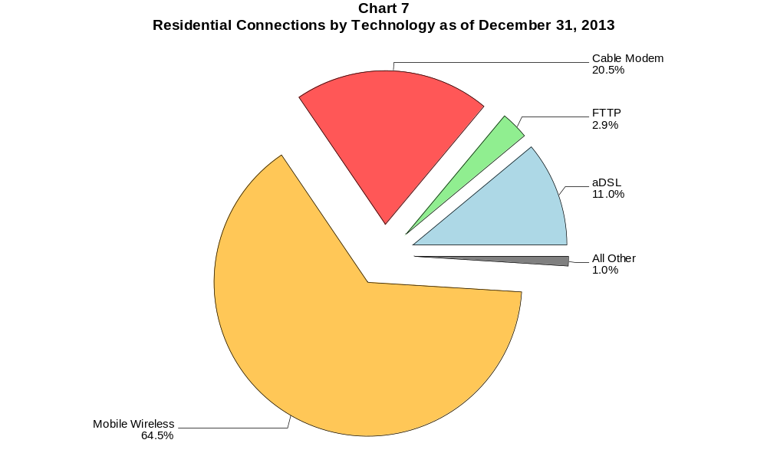

Table 7
Connections at Least 3 Mbps Downstream and 768 kbps Upstream by Technology 2009-2013
(In thousands)

 | 2009 | 2010 |  | 2011 |  | 2012 |  | 2013
Technology | Dec | Jun | Dec | Jun | Dec | Jun | Dec | Jun | Dec
Total | 40,669 | 45,552 | 55,110 | 64,819 | 82,015 | 100,268 | 129,398 | 165,110 | 211,218
Total Fixed | 38,963 | 41,364 | 44,694 | 48,577 | 51,097 | 57,243 | 64,657 | 68,673 | 78,175
aDSL | 6,389 | 6,275 | 7,302 | 8,909 | 10,351 | 12,875 | 13,108 | 14,233 | 18,540
sDSL | 19 | 13 | 14 | 16 | 26 | 30 | 33 | 34 | 36
Other Wireline¹ | 150 | 177 | 211 | 204 | 228 | 239 | 276 | 284 | 308
Cable Modem | 28,583 | 30,616 | 32,338 | 34,113 | 34,699 | 37,798 | 44,133 | 46,014 | 50,236
FTTP² | 3,739 | 4,192 | 4,725 | 5,188 | 5,606 | 6,001 | 6,430 | 6,981 | 7,486
Satellite | # | # | # | # | # | 87 | 394 | 791 | 1,181
Fixed Wireless | 82 | 92 | 105 | 145 | 186 | 214 | 284 | 337 | 388
Mobile Wireless | 1,706 | 4,188 | 10,416 | 16,242 | 30,918 | 43,025 | 64,741 | 96,437 | 133,043

# = Rounds to Zero.
¹ Power Line and Other are summarized with Other Wireline to maintain firm confidentiality. No Power Line connections were reported after 2012. See Technical
Notes at the end of the report for a description of Form 477 technology categories and other reporting requirements.
² Fiber to the premises.
Note: Some historical data have been revised. Figures may not sum to totals due to rounding.
Source: FCC Form 477, Part I.

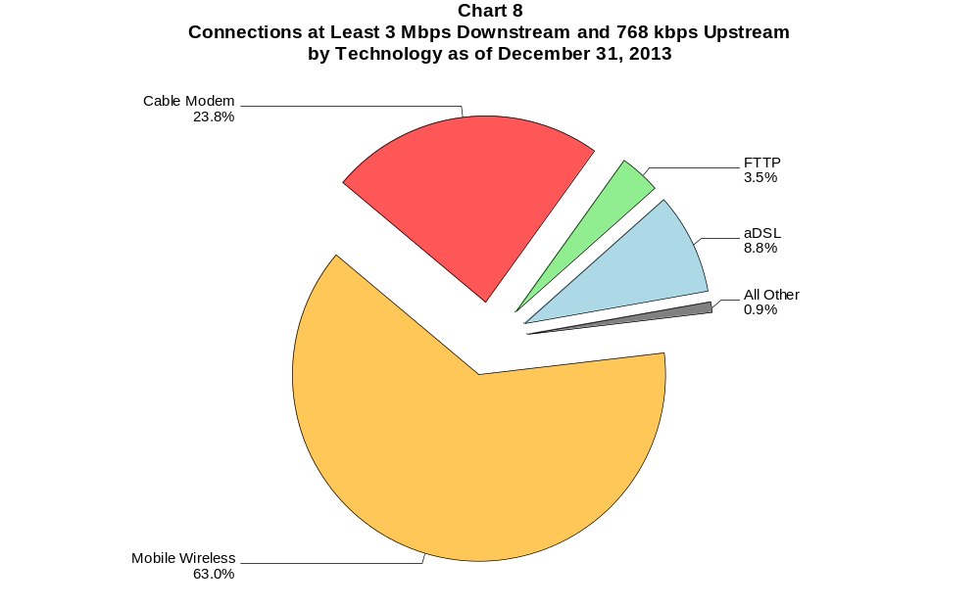

Table 8
Residential Connections at Least 3 Mbps Downstream and 768 kbps Upstream by Technology 2009-2013
(In thousands)

 | 2009 | 2010 |  | 2011 |  | 2012 |  | 2013
Technology | Dec | Jun | Dec | Jun | Dec | Jun | Dec | Jun | Dec
Total | 38,426 | 42,243 | 47,632 | 51,783 | 63,736 | 78,609 | 105,749 | 137,792 | 179,840
Total Fixed | 36,844 | 39,037 | 41,769 | 45,263 | 47,427 | 53,070 | 59,914 | 63,342 | 72,476
aDSL | 5,633 | 5,557 | 6,421 | 7,909 | 9,274 | 11,563 | 11,669 | 12,666 | 16,715
sDSL | 10 | 2 | 2 | 4 | 12 | 12 | 13 | 13 | 13
Other Wireline¹ | 19 | 20 | 36 | 15 | 16 | 7 | 20 | 21 | 20
Cable Modem | 27,548 | 29,398 | 30,742 | 32,321 | 32,693 | 35,583 | 41,561 | 43,061 | 47,258
FTTP² | 3,566 | 3,982 | 4,482 | 4,894 | 5,271 | 5,632 | 6,012 | 6,504 | 6,958
Satellite | 0 | 0 | 0 | 0 | # | 86 | 393 | 788 | 1,177
Fixed Wireless | 68 | 77 | 86 | 121 | 161 | 185 | 245 | 289 | 335
Mobile Wireless | 1,582 | 3,206 | 5,863 | 6,520 | 16,309 | 25,539 | 45,835 | 74,450 | 107,364

# = Rounds to Zero.
¹ Power Line and Other are summarized with Other Wireline to maintain firm confidentiality. No Power Line connections were reported after 2012. See Technical
Notes at the end of the report for a description of Form 477 technology categories and other reporting requirements.
² Fiber to the premises.
Note: Some historical data have been revised. Figures may not sum to totals due to rounding.
Source: FCC Form 477, Part I.

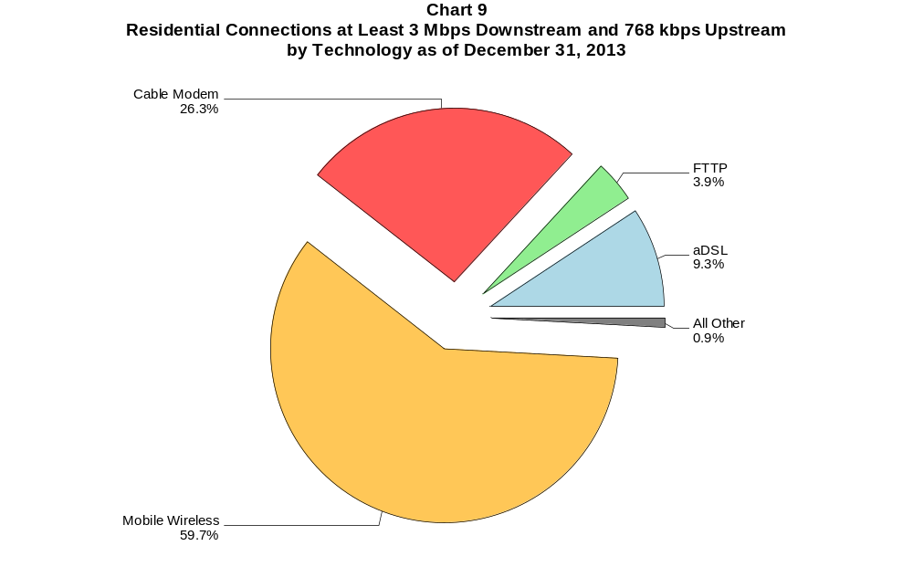

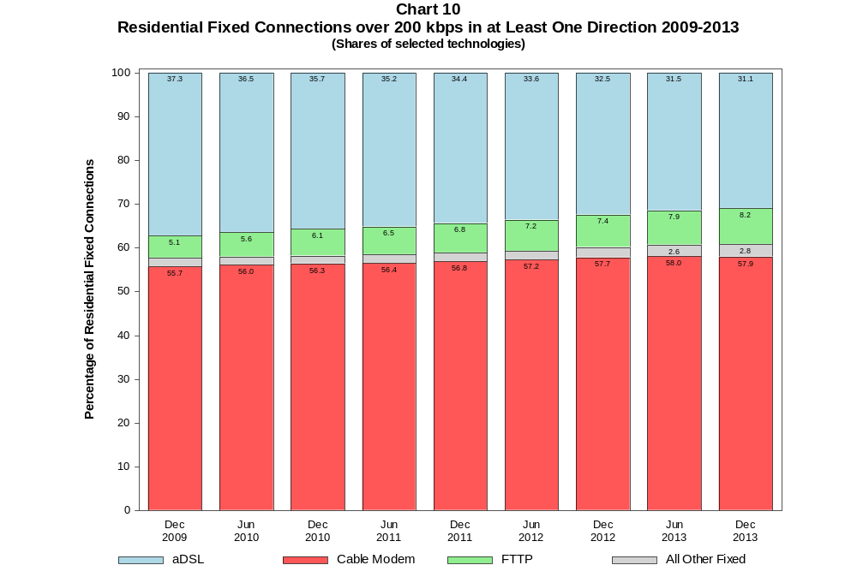

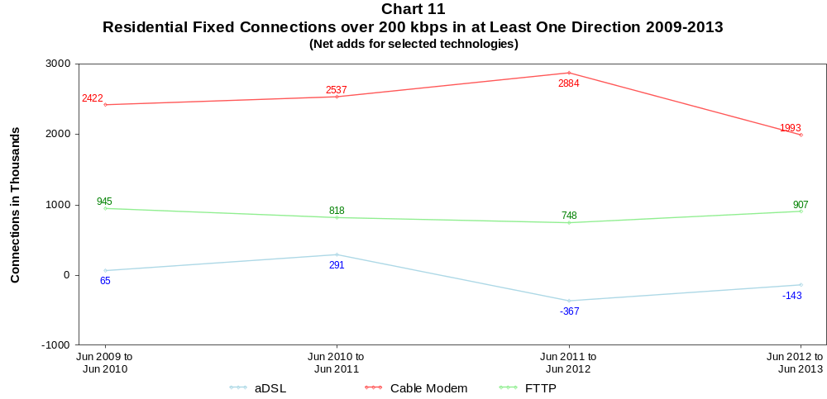

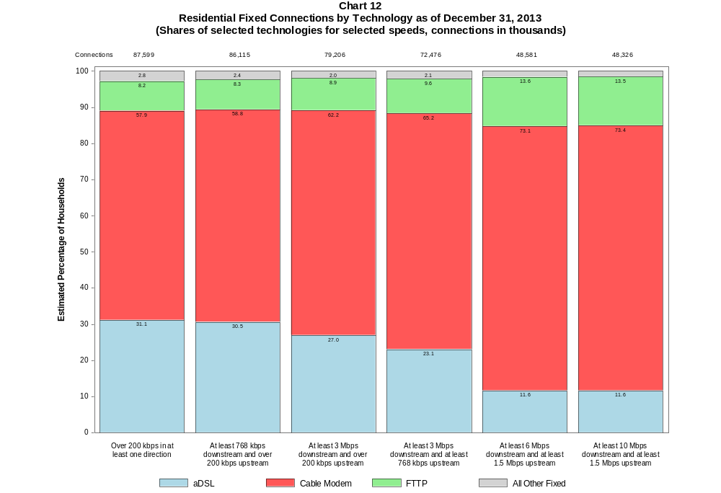

Table 9
Residential Connections by Technology and Speed (BTOP/BIP Definition)
as of December 31, 2013
(In thousands)

Technology | At Most  200 kbps  Upstream or  less than  768 kbps  Downstream | Over  200 kbps  Upstream and  at least  768 kbps  Downstream | Total
aDSL | 943 | 26,305 | 27,248
sDSL | 7 | 32 | 39
Other Wireline | # | 22 | 22
Cable Modem | 114 | 50,595 | 50,709
FTTP | 9 | 7,168 | 7,176
Satellite | 344 | 1,298 | 1,643
Fixed Wireless | 67 | 696 | 763
Mobile Wireless | 25,490 | 133,708 | 159,197
Total | 26,974 | 219,823 | 246,797

# = Rounds to Zero.
Note: Figures may not sum to totals due to rounding.
Source: FCC Form 477, Parts I and VI.

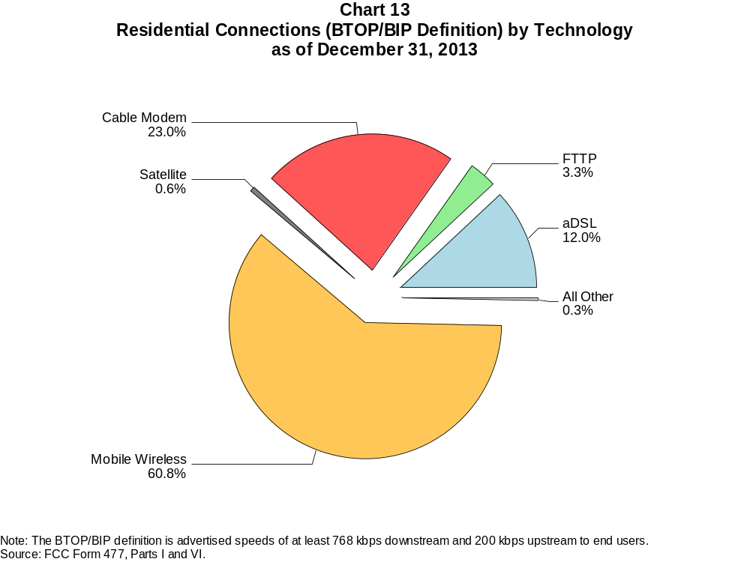

Table 10
Connections by Downstream Speed Tier and Technology as of December 31, 2013
(In thousands)

 | Downstream Speed
Technology | Greater than 200  kbps and less than  768 kbps | At least 768 kbps  and less than  1.5 Mbps | At least 1.5 Mbps  and less than  3 Mbps | At least 3 Mbps  and less than  6 Mbps | At least 6 Mbps  and less than  10 Mbps | At least 10 Mbps  and less than  25 Mbps | At least 25 Mbps  and less than  100 Mbps | At least 100 Mbps | Total
aDSL | 407 | 2,277 | 3,948 | 8,738 | 6,212 | 8,834 | 273 | 2 | 30,690
sDSL | 21 | 32 | 19 | * | * | * | 4 | # | 108
Other Wireline | 35 | 38 | 391 | 113 | 29 | 68 | 57 | 40 | 772
Cable Modem | 100 | 903 | 574 | 3,939 | 1,630 | 19,096 | 27,240 | 527 | 54,009
FTTP | 11 | 84 | 97 | 286 | 197 | 4,021 | 2,864 | 185 | 7,745
Satellite | 215 | 285 | 159 | * | * | * | 0 | 0 | 1,849
Fixed Wireless | 58 | 133 | 242 | 275 | 79 | 67 | 4 | 1 | 858
Mobile Wireless | 31,232 | 3,899 | 23,676 | 55,128 | 25,803 | 49,167 | 8,460 | 0 | 197,365
Total | 32,079 | 7,651 | 29,106 | 68,815 | 33,954 | 82,135 | 38,901 | 756 | 293,397

Percentages

aDSL | 0.1 | 0.8 | 1.3 | 3.0 | 2.1 | 3.0 | 0.1 | 0.0 | 10.5
sDSL | 0.0 | 0.0 | 0.0 | * | * | * | 0.0 | 0.0 | 0.0
Other Wireline | 0.0 | 0.0 | 0.1 | 0.0 | 0.0 | 0.0 | 0.0 | 0.0 | 0.3
Cable Modem | 0.0 | 0.3 | 0.2 | 1.3 | 0.6 | 6.5 | 9.3 | 0.2 | 18.4
FTTP | 0.0 | 0.0 | 0.0 | 0.1 | 0.1 | 1.4 | 1.0 | 0.1 | 2.6
Satellite | 0.1 | 0.1 | 0.1 | * | * | * | 0.0 | 0.0 | 0.6
Fixed Wireless | 0.0 | 0.0 | 0.1 | 0.1 | 0.0 | 0.0 | 0.0 | 0.0 | 0.3
Mobile Wireless | 10.6 | 1.3 | 8.1 | 18.8 | 8.8 | 16.8 | 2.9 | 0.0 | 67.3
Total | 10.9 | 2.6 | 9.9 | 23.5 | 11.6 | 28.0 | 13.3 | 0.3 | 100.0

# = Rounds to Zero.
* = Data withheld to maintain firm confidentiality.
Note: Figures may not sum to totals due to rounding.
Source: FCC Form 477, Part I.

Table 11
Residential Connections by Downstream Speed Tier and Technology as of December 31, 2013
(In thousands)

 | Downstream Speed
Technology | Greater than 200  kbps and less than  768 kbps | At least 768 kbps  and less than  1.5 Mbps | At least 1.5 Mbps  and less than  3 Mbps | At least 3 Mbps  and less than  6 Mbps | At least 6 Mbps  and less than  10 Mbps | At least 10 Mbps  and less than  25 Mbps | At least 25 Mbps  and less than  100 Mbps | At least 100 Mbps | Total
aDSL | 357 | 2,150 | 3,386 | 7,665 | 5,194 | 8,237 | 258 | 1 | 27,248
sDSL | 7 | 16 | 2 | * | * | * | 3 | 0 | 39
Other Wireline | # | # | 1 | 4 | 3 | 9 | 1 | 3 | 22
Cable Modem | 88 | 877 | 497 | 3,692 | 1,085 | 17,488 | 26,513 | 468 | 50,709
FTTP | 8 | 77 | 71 | 252 | 180 | 3,794 | 2,682 | 112 | 7,176
Satellite | 86 | 252 | 123 | * | * | * | 0 | 0 | 1,643
Fixed Wireless | 54 | 120 | 219 | 241 | 68 | 59 | 2 | # | 763
Mobile Wireless | 24,379 | 3,736 | 19,123 | 46,823 | 16,168 | 41,109 | 7,859 | 0 | 159,197
Total | 24,981 | 7,228 | 23,423 | 58,993 | 22,699 | 71,569 | 37,318 | 585 | 246,797

Percentages

aDSL | 0.1 | 0.9 | 1.4 | 3.1 | 2.1 | 3.3 | 0.1 | 0.0 | 11.0
sDSL | 0.0 | 0.0 | 0.0 | * | * | * | 0.0 | 0.0 | 0.0
Other Wireline | 0.0 | 0.0 | 0.0 | 0.0 | 0.0 | 0.0 | 0.0 | 0.0 | 0.0
Cable Modem | 0.0 | 0.4 | 0.2 | 1.5 | 0.4 | 7.1 | 10.7 | 0.2 | 20.5
FTTP | 0.0 | 0.0 | 0.0 | 0.1 | 0.1 | 1.5 | 1.1 | 0.0 | 2.9
Satellite | 0.0 | 0.1 | 0.0 | * | * | * | 0.0 | 0.0 | 0.7
Fixed Wireless | 0.0 | 0.0 | 0.1 | 0.1 | 0.0 | 0.0 | 0.0 | 0.0 | 0.3
Mobile Wireless | 9.9 | 1.5 | 7.7 | 19.0 | 6.6 | 16.7 | 3.2 | 0.0 | 64.5
Total | 10.1 | 2.9 | 9.5 | 23.9 | 9.2 | 29.0 | 15.1 | 0.2 | 100.0

# = Rounds to Zero.
* = Data withheld to maintain firm confidentiality.
Note: Figures may not sum to totals due to rounding.
Source: FCC Form 477, Part I.

Table 12
Nationwide Number of Providers of Connections over 200 kbps in at Least One Direction
by Technology 2009-2013

 | 2009 | 2010 |  | 2011 |  | 2012 |  | 2013
Technology | Dec | Jun | Dec | Jun | Dec | Jun | Dec | Jun | Dec
aDSL | 862 | 875 | 865 | 867 | 867 | 860 | 865 | 852 | 851
sDSL | 261 | 251 | 247 | 252 | 255 | 251 | 255 | 246 | 239
Other Wireline | 274 | 267 | 270 | 265 | 274 | 258 | 262 | 246 | 245
Cable Modem | 345 | 345 | 357 | 400 | 405 | 401 | 404 | 403 | 407
FTTP | 485 | 510 | 545 | 579 | 621 | 642 | 666 | 692 | 744
Satellite | 4 | 4 | 4 | 5 | 6 | 5 | 6 | 5 | 5
Fixed Wireless | 607 | 625 | 646 | 672 | 713 | 713 | 765 | 771 | 825
Mobile Wireless | 51 | 55 | 57 | 64 | 69 | 67 | 70 | 79 | 77
Power Line and Other | 6 | 5 | 7 | 4 | 5 | * | * | 0 | 1
Total | 1,526 | 1,536 | 1,566 | 1,624 | 1,687 | 1,673 | 1,722 | 1,714 | 1,773

Note: Some historical data have been revised. Multiple Form 477 filers within a holding company structure count as one provider. * = 1-3 providers.
Source: FCC Form 477, Part I.

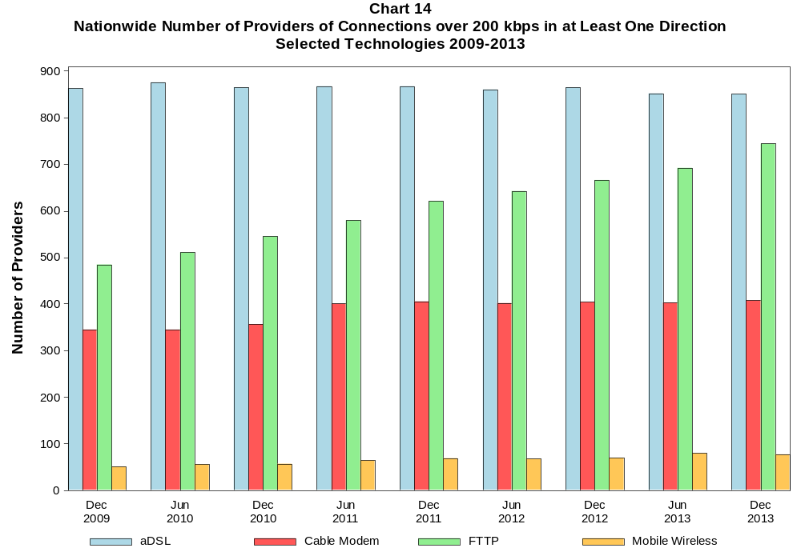

Table 13
Residential Fixed Connections at Least 3 Mbps Downstream / 768 kbps Upstream
and Households by State as of December 31, 2013
(Connections and households, in thousands)
State | Connections | Households | Subscribership  Ratio
Alabama | 775 | 1,920 | 0.40
Alaska | 127 | 269 | 0.47
American Samoa | 0 | 9 | 0.00
Arizona | 1,563 | 2,496 | 0.63
Arkansas | 417 | 1,174 | 0.36
California | 8,419 | 12,912 | 0.65
Colorado | 1,409 | 2,054 | 0.69
Connecticut | 947 | 1,387 | 0.68
Delaware | 260 | 355 | 0.73
District of Columbia | 192 | 276 | 0.69
Florida | 4,835 | 7,733 | 0.63
Georgia | 1,940 | 3,739 | 0.52
Guam | * | 40 | *
Hawaii | 379 | 470 | 0.81
Idaho | 291 | 605 | 0.48
Illinois | 2,787 | 4,876 | 0.57
Indiana | 1,334 | 2,542 | 0.52
Iowa | 401 | 1,236 | 0.32
Kansas | 593 | 1,130 | 0.52
Kentucky | 853 | 1,753 | 0.49
Louisiana | 736 | 1,744 | 0.42
Maine | 376 | 561 | 0.67
Maryland | 1,612 | 2,211 | 0.73
Massachusetts | 2,037 | 2,575 | 0.79
Michigan | 2,236 | 3,856 | 0.58
Minnesota | 1,206 | 2,128 | 0.57
Mississippi | 346 | 1,127 | 0.31
Missouri | 1,130 | 2,413 | 0.47
Montana | 192 | 420 | 0.46
Nebraska | 432 | 734 | 0.59
Nevada | 621 | 1,068 | 0.58
New Hampshire | 402 | 525 | 0.77
New Jersey | 2,607 | 3,250 | 0.80
New Mexico | 376 | 818 | 0.46
New York | 5,677 | 7,363 | 0.77
North Carolina | 2,287 | 3,910 | 0.58
North Dakota | 168 | 288 | 0.58
Northern Mariana Isl | * | 11 | *
Ohio | 2,804 | 4,612 | 0.61
Oklahoma | 652 | 1,497 | 0.44
Oregon | 993 | 1,567 | 0.63
Pennsylvania | 3,283 | 5,059 | 0.65
Puerto Rico | 173 | 1,373 | 0.13
Rhode Island | 307 | 413 | 0.74
South Carolina | 1,033 | 1,871 | 0.55
South Dakota | 191 | 330 | 0.58
Tennessee | 1,271 | 2,567 | 0.50
Texas | 5,233 | 9,383 | 0.56
Utah | 609 | 923 | 0.66
Vermont | 182 | 257 | 0.71
Virgin Islands | 7 | 41 | 0.16
Virginia | 2,071 | 3,155 | 0.66
Washington | 1,845 | 2,723 | 0.68
West Virginia | 434 | 767 | 0.57
Wisconsin | 1,296 | 2,314 | 0.56
Wyoming | 114 | 235 | 0.49
Total | 72,476 | 121,061 | 0.60

# = Rounds to Zero; * = Data withheld to maintain firm confidentiality.
Note: Figures may not sum to totals due to rounding.
Sources: FCC Form 477, Part VI (Connections); Geolytics 2013 Block-Level Estimates (Households for U.S. and District of Columbia);
Census 2010 (Housing Units for Puerto Rico, American Samoa, Guam, Northern Mariana Islands and U.S. Virgin Islands).

Table 14
Residential Fixed Connections and Households by State as of December 31, 2013
(Connections over 200 kbps in at least one direction and households, in thousands)

State | Connections | Households | Subscribership  Ratio
Alabama | 1,145 | 1,920 | 0.60
Alaska | 194 | 269 | 0.72
American Samoa | * | 9 | *
Arizona | 1,830 | 2,496 | 0.73
Arkansas | 645 | 1,174 | 0.55
California | 10,115 | 12,912 | 0.78
Colorado | 1,620 | 2,054 | 0.79
Connecticut | 1,102 | 1,387 | 0.79
Delaware | 284 | 355 | 0.80
District of Columbia | 205 | 276 | 0.74
Florida | 6,024 | 7,733 | 0.78
Georgia | 2,516 | 3,739 | 0.67
Guam | * | 40 | *
Hawaii | 393 | 470 | 0.84
Idaho | 412 | 605 | 0.68
Illinois | 3,450 | 4,876 | 0.71
Indiana | 1,704 | 2,542 | 0.67
Iowa | 839 | 1,236 | 0.68
Kansas | 802 | 1,130 | 0.71
Kentucky | 1,135 | 1,753 | 0.65
Louisiana | 1,101 | 1,744 | 0.63
Maine | 430 | 561 | 0.77
Maryland | 1,707 | 2,211 | 0.77
Massachusetts | 2,125 | 2,575 | 0.83
Michigan | 2,672 | 3,856 | 0.69
Minnesota | 1,534 | 2,128 | 0.72
Mississippi | 570 | 1,127 | 0.51
Missouri | 1,575 | 2,413 | 0.65
Montana | 285 | 420 | 0.68
Nebraska | 520 | 734 | 0.71
Nevada | 747 | 1,068 | 0.70
New Hampshire | 441 | 525 | 0.84
New Jersey | 2,719 | 3,250 | 0.84
New Mexico | 501 | 818 | 0.61
New York | 5,955 | 7,363 | 0.81
North Carolina | 2,819 | 3,910 | 0.72
North Dakota | 215 | 288 | 0.75
Northern Mariana Isl | * | 11 | *
Ohio | 3,384 | 4,612 | 0.73
Oklahoma | 924 | 1,497 | 0.62
Oregon | 1,144 | 1,567 | 0.73
Pennsylvania | 3,759 | 5,059 | 0.74
Puerto Rico | 564 | 1,373 | 0.41
Rhode Island | 320 | 413 | 0.78
South Carolina | 1,294 | 1,871 | 0.69
South Dakota | 232 | 330 | 0.70
Tennessee | 1,578 | 2,567 | 0.61
Texas | 6,479 | 9,383 | 0.69
Utah | 706 | 923 | 0.76
Vermont | 208 | 257 | 0.81
Virgin Islands | 23 | 41 | 0.57
Virginia | 2,282 | 3,155 | 0.72
Washington | 2,068 | 2,723 | 0.76
West Virginia | 489 | 767 | 0.64
Wisconsin | 1,618 | 2,314 | 0.70
Wyoming | 160 | 235 | 0.68
Total | 87,599 | 121,061 | 0.72

# = Rounds to Zero; * = Data withheld to maintain firm confidentiality.
Note: Figures may not sum to totals due to rounding.
Sources: FCC Form 477, Part VI (Connections); Geolytics 2013 Block-Level Estimates (Households for U.S. and District of Columbia);
Census 2010 (Housing Units for Puerto Rico, American Samoa, Guam, Northern Mariana Islands and U.S. Virgin Islands).

Table 15
Connections by Type of End User by State as of December 31, 2013
(Connections over 200 kbps in at least one direction, in thousands)

 | Connections |  | Percentages
State | Residential | Business | Residential | Business | Total
Alabama | 3,345 | 478 | 87.5 | 12.5 | 3,823
Alaska | 580 | 97 | 85.7 | 14.3 | 677
American Samoa | * | * | * | * | *
Arizona | 4,815 | 819 | 85.5 | 14.5 | 5,634
Arkansas | 1,997 | 341 | 85.4 | 14.6 | 2,338
California | 32,677 | 6,065 | 84.3 | 15.7 | 38,742
Colorado | 4,331 | 823 | 84.0 | 16.0 | 5,154
Connecticut | 3,008 | 598 | 83.4 | 16.6 | 3,606
Delaware | 758 | 139 | 84.5 | 15.5 | 897
District of Columbia | 692 | 521 | 57.0 | 43.0 | 1,213
Florida | 15,968 | 3,041 | 84.0 | 16.0 | 19,009
Georgia | 7,475 | 1,385 | 84.4 | 15.6 | 8,860
Guam | 67 | 11 | 86.1 | 13.9 | 78
Hawaii | 1,190 | 177 | 87.0 | 13.0 | 1,367
Idaho | 1,138 | 203 | 84.8 | 15.2 | 1,341
Illinois | 9,934 | 2,019 | 83.1 | 16.9 | 11,952
Indiana | 4,645 | 709 | 86.8 | 13.2 | 5,354
Iowa | 2,009 | 360 | 84.8 | 15.2 | 2,369
Kansas | 2,050 | 379 | 84.4 | 15.6 | 2,429
Kentucky | 3,182 | 449 | 87.6 | 12.4 | 3,631
Louisiana | 3,545 | 577 | 86.0 | 14.0 | 4,121
Maine | 894 | 142 | 86.3 | 13.7 | 1,036
Maryland | 4,851 | 885 | 84.6 | 15.4 | 5,737
Massachusetts | 5,622 | 1,089 | 83.8 | 16.2 | 6,711
Michigan | 7,173 | 1,632 | 81.5 | 18.5 | 8,805
Minnesota | 4,017 | 884 | 82.0 | 18.0 | 4,902
Mississippi | 2,083 | 178 | 92.1 | 7.9 | 2,261
Missouri | 4,271 | 901 | 82.6 | 17.4 | 5,172
Montana | 728 | 105 | 87.4 | 12.6 | 833
Nebraska | 1,312 | 286 | 82.1 | 17.9 | 1,598
Nevada | 2,243 | 357 | 86.3 | 13.7 | 2,600
New Hampshire | 1,038 | 169 | 86.0 | 14.0 | 1,207
New Jersey | 7,783 | 1,495 | 83.9 | 16.1 | 9,279
New Mexico | 1,422 | 226 | 86.3 | 13.7 | 1,648
New York | 16,108 | 3,193 | 83.5 | 16.5 | 19,300
North Carolina | 7,025 | 1,320 | 84.2 | 15.8 | 8,346
North Dakota | 568 | 108 | 84.1 | 15.9 | 676
Northern Mariana Isl | * | * | * | * | *
Ohio | 8,695 | 1,628 | 84.2 | 15.8 | 10,323
Oklahoma | 2,809 | 499 | 84.9 | 15.1 | 3,308
Oregon | 3,039 | 538 | 85.0 | 15.0 | 3,577
Pennsylvania | 9,742 | 1,697 | 85.2 | 14.8 | 11,439
Puerto Rico | 2,188 | 216 | 91.0 | 9.0 | 2,404
Rhode Island | 826 | 153 | 84.4 | 15.6 | 978
South Carolina | 3,243 | 476 | 87.2 | 12.8 | 3,719
South Dakota | 591 | 82 | 87.9 | 12.1 | 673
Tennessee | 4,626 | 829 | 84.8 | 15.2 | 5,455
Texas | 20,698 | 4,380 | 82.5 | 17.5 | 25,078
Utah | 2,009 | 409 | 83.1 | 16.9 | 2,418
Vermont | 450 | 86 | 84.0 | 16.0 | 536
Virgin Islands | 83 | 9 | 89.8 | 10.2 | 93
Virginia | 6,326 | 1,326 | 82.7 | 17.3 | 7,652
Washington | 5,544 | 1,136 | 83.0 | 17.0 | 6,680
West Virginia | 1,157 | 166 | 87.4 | 12.6 | 1,323
Wisconsin | 3,786 | 742 | 83.6 | 16.4 | 4,529
Wyoming | 431 | 66 | 86.7 | 13.3 | 497
Total | 246,797 | 46,601 | 84.1 | 15.9 | 293,397

# = Rounds to Zero.
* = Data withheld to maintain firm confidentiality.
Figures may not sum to totals due to rounding.
Source: FCC Form 477, Part I and VI.

Table 16
Connections by Technology by State as of December 31, 2013
(Connections over 200 kbps in at least one direction, in thousands)

State | ADSL | SDSL | Other  Wireline | Cable  Modem | Fiber | Satellite | Fixed  Wireless | Mobile  Wireless | Total
Alabama | 527 | 4 | * | 648 | 11 | * | 4 | 2,561 | 3,823
Alaska | 82 | 1 | 3 | * | 2 | * | 6 | 442 | 677
American Samoa | * | * | 0 | * | * | 0 | * | 0 | *
Arizona | 649 | # | * | 1,253 | 6 | * | 20 | 3,662 | 5,634
Arkansas | 350 | # | * | 324 | 11 | * | 3 | 1,601 | 2,338
California | 4,205 | 11 | * | 5,735 | 830 | * | 46 | 27,656 | 38,742
Colorado | * | # | 0 | 952 | 7 | * | 52 | 3,380 | 5,154
Connecticut | * | 1 | 0 | 783 | 6 | * | * | 2,399 | 3,606
Delaware | * | # | 0 | 181 | * | * | * | 589 | 897
District of Columbia | * | 1 | 0 | * | 26 | * | * | 974 | 1,213
Florida | 1,928 | 1 | * | 4,060 | 469 | * | 6 | 12,425 | 19,009
Georgia | 1,223 | 2 | * | 1,420 | 43 | * | 1 | 6,083 | 8,860
Guam | * | * | * | * | * | 0 | * | * | 78
Hawaii | * | * | 0 | * | 9 | * | * | 942 | 1,367
Idaho | 219 | # | * | 168 | 4 | * | 43 | 890 | 1,341
Illinois | 1,470 | 6 | * | 2,145 | 26 | * | 54 | 8,171 | 11,952
Indiana | 747 | 1 | * | 910 | 95 | * | 39 | 3,503 | 5,354
Iowa | 386 | 1 | * | 413 | 62 | * | 29 | 1,447 | 2,369
Kansas | 286 | 1 | * | 469 | 69 | * | 30 | 1,549 | 2,429
Kentucky | 508 | 2 | * | 637 | 30 | * | 15 | 2,387 | 3,631
Louisiana | 433 | 1 | * | 675 | 49 | * | 6 | 2,900 | 4,121
Maine | 140 | 3 | 0 | 315 | 6 | * | * | 558 | 1,036
Maryland | * | 2 | 0 | 912 | * | * | 1 | 3,883 | 5,737
Massachusetts | * | 1 | 0 | 1,568 | * | * | 2 | 4,383 | 6,711
Michigan | 904 | 6 | * | 1,835 | 13 | * | 38 | 5,900 | 8,805
Minnesota | 631 | 14 | * | 914 | 49 | * | 23 | 3,228 | 4,902
Mississippi | 300 | # | * | 280 | 3 | * | 1 | 1,624 | 2,261
Missouri | 850 | # | * | 726 | 35 | * | 27 | 3,446 | 5,172
Montana | 119 | 1 | * | 161 | 11 | * | 13 | 513 | 833
Nebraska | 181 | # | * | 345 | 16 | * | 19 | 1,025 | 1,598

Table 16 - Continued
Connections by Technology by State as of December 31, 2013
(Connections over 200 kbps in at least one direction, in thousands)

State | ADSL | SDSL | Other  Wireline | Cable  Modem | Fiber | Satellite | Fixed  Wireless | Mobile  Wireless | Total
Nevada | 257 | # | 0 | * | 5 | * | 8 | 1,786 | 2,600
New Hampshire | 93 | # | 0 | 373 | 15 | * | * | 716 | 1,207
New Jersey | 310 | 1 | 0 | 1,890 | * | * | # | 6,274 | 9,279
New Mexico | 293 | # | * | 216 | 5 | * | 19 | 1,096 | 1,648
New York | 723 | 6 | 0 | 4,525 | * | * | 2 | 12,725 | 19,300
North Carolina | 1,071 | # | * | 1,886 | 47 | * | 3 | 5,271 | 8,346
North Dakota | 70 | 1 | * | 123 | 40 | * | 4 | 431 | 676
Northern Mariana Isl | * | 0 | * | * | * | 0 | * | * | *
Ohio | 1,205 | 3 | * | 2,279 | 70 | * | 32 | 6,664 | 10,323
Oklahoma | 397 | # | * | 519 | 19 | * | 28 | 2,285 | 3,308
Oregon | 364 | 1 | * | 747 | 86 | * | 18 | 2,327 | 3,577
Pennsylvania | 943 | 3 | 0 | 2,390 | * | * | 4 | 7,336 | 11,439
Puerto Rico | * | 0 | 0 | * | * | * | * | 1,773 | 2,404
Rhode Island | * | # | 0 | * | * | * | * | 628 | 978
South Carolina | 473 | * | 0 | 841 | 46 | * | * | 2,310 | 3,719
South Dakota | 63 | * | 0 | 145 | 27 | * | 12 | 416 | 673
Tennessee | 593 | 2 | * | 959 | 102 | * | 8 | 3,714 | 5,455
Texas | 3,139 | 4 | * | 3,037 | 532 | * | 100 | 17,979 | 25,078
Utah | 314 | # | * | 365 | 33 | * | 46 | 1,647 | 2,418
Vermont | 99 | * | 0 | 118 | 9 | * | * | 298 | 536
Virgin Islands | * | 0 | * | * | * | * | * | 66 | 93
Virginia | 421 | 1 | 0 | 1,268 | * | * | 7 | 5,158 | 7,652
Washington | 595 | 1 | * | 1,492 | 85 | * | 18 | 4,431 | 6,680
West Virginia | * | * | 0 | 312 | 3 | * | 2 | 792 | 1,323
Wisconsin | 663 | 11 | * | 968 | 35 | * | 33 | 2,769 | 4,529
Wyoming | 62 | # | * | 95 | 3 | * | 12 | 314 | 497
Total | 30,690 | 108 | 772 | 54,009 | 7,745 | 1,849 | 858 | 197,365 | 293,397

# = Rounds to Zero.
* = Data withheld to maintain firm confidentiality.
Figures may not sum to totals due to rounding.
Source: FCC Form 477, Part I.

Table 17
Connections by Technology by State as of December 31, 2013
(Connections at least 3 Mbps downstream and 768 kbps upstream, in thousands)

State | ADSL | SDSL | Other  Wireline | Cable  Modem | Fiber | Satellite | Fixed  Wireless | Mobile  Wireless | Total
Alabama | 236 | # | * | 550 | 10 | * | 1 | 1,755 | 2,596
Alaska | 46 | * | 1 | * | 2 | * | 2 | 76 | 218
American Samoa | 0 | * | 0 | 0 | * | 0 | 0 | 0 | *
Arizona | 488 | * | 7 | 1,122 | 5 | * | 10 | 2,308 | 3,954
Arkansas | 173 | * | 2 | 245 | 8 | * | 1 | 1,136 | 1,597
California | 2,521 | 3 | * | 5,486 | 811 | * | 29 | 18,916 | 27,897
Colorado | * | # | 11 | 946 | 6 | * | 41 | 2,225 | 3,744
Connecticut | * | * | 2 | 776 | 5 | * | * | 1,667 | 2,687
Delaware | * | * | 1 | * | * | * | 0 | 398 | 679
District of Columbia | * | * | 5 | * | * | * | * | 635 | 856
Florida | 1,143 | # | * | 3,542 | 461 | * | 4 | 9,393 | 14,606
Georgia | 648 | # | * | 1,355 | 36 | * | # | 4,287 | 6,375
Guam | * | * | * | * | * | 0 | * | * | 50
Hawaii | * | * | # | * | 9 | * | * | 677 | 1,085
Idaho | 159 | * | 1 | 127 | 3 | * | 23 | 546 | 865
Illinois | 925 | 3 | * | 1,998 | 24 | * | 28 | 5,741 | 8,762
Indiana | 477 | # | * | 821 | 90 | * | 10 | 2,394 | 3,831
Iowa | 219 | # | * | 153 | 46 | * | 15 | 846 | 1,299
Kansas | 151 | # | * | 409 | 54 | * | 6 | 664 | 1,296
Kentucky | 281 | # | * | 575 | 20 | * | 5 | 681 | 1,597
Louisiana | * | # | 3 | 554 | 34 | * | 1 | 2,137 | 2,928
Maine | 104 | 1 | # | 297 | 5 | * | * | 229 | 643
Maryland | * | * | 7 | 896 | * | * | 1 | 2,609 | 4,344
Massachusetts | * | # | 9 | 1,562 | * | * | 1 | 2,982 | 5,198
Michigan | 580 | 2 | * | 1,711 | 12 | * | 17 | 4,012 | 6,399
Minnesota | 397 | 10 | * | 831 | 37 | * | 5 | 2,257 | 3,561
Mississippi | 110 | * | 1 | 235 | 2 | * | 1 | 783 | 1,165
Missouri | 481 | # | * | 643 | 29 | * | 5 | 2,500 | 3,710
Montana | 52 | # | 1 | * | 9 | * | 5 | * | 444
Nebraska | 126 | # | * | 313 | 12 | * | 8 | 600 | 1,065

Table 17 - Continued
Connections by Technology by State as of December 31, 2013
(Connections at least 3 Mbps downstream and 768 kbps upstream, in thousands)

State | ADSL | SDSL | Other  Wireline | Cable  Modem | Fiber | Satellite | Fixed  Wireless | Mobile  Wireless | Total
Nevada | 151 | * | 3 | * | 4 | * | 6 | 1,280 | 1,935
New Hampshire | 59 | # | * | 363 | 14 | * | 0 | 446 | 887
New Jersey | 199 | # | 13 | 1,882 | * | * | # | 4,308 | 7,163
New Mexico | 185 | # | 2 | 209 | 3 | * | 3 | * | 905
New York | 537 | 2 | 21 | 4,415 | * | * | 1 | 8,902 | 15,110
North Carolina | 582 | # | * | 1,794 | 38 | * | # | 3,301 | 5,757
North Dakota | 44 | * | 2 | 107 | 34 | * | 1 | * | 391
Northern Mariana Isl | * | 0 | 0 | 0 | * | 0 | * | * | *
Ohio | 817 | # | * | 2,072 | 66 | * | 6 | 4,290 | 7,293
Oklahoma | 192 | * | 1 | 440 | 15 | * | 12 | 1,738 | 2,437
Oregon | 216 | # | * | 742 | 84 | * | 10 | 1,603 | 2,676
Pennsylvania | 636 | # | 11 | 2,206 | * | * | 3 | 5,056 | 8,629
Puerto Rico | * | 0 | * | * | * | * | * | 970 | 1,152
Rhode Island | * | * | 1 | * | * | * | * | 426 | 759
South Carolina | 247 | # | * | 794 | 37 | * | # | 1,449 | 2,556
South Dakota | 46 | * | # | 132 | 25 | * | 2 | * | 379
Tennessee | 281 | 2 | * | 945 | 96 | * | 1 | 2,342 | 3,716
Texas | 2,066 | 1 | * | 2,807 | 504 | * | 51 | 13,475 | 19,077
Utah | 216 | # | * | 360 | 32 | * | 43 | 1,140 | 1,796
Vermont | 73 | * | # | 117 | 8 | * | * | * | 291
Virgin Islands | * | 0 | * | * | * | 0 | * | * | 15
Virginia | 258 | # | 11 | 1,223 | * | * | 3 | 3,289 | 5,525
Washington | 378 | # | * | 1,484 | 82 | * | 6 | 3,165 | 5,146
West Virginia | * | * | # | 282 | 2 | * | 2 | 168 | 635
Wisconsin | 387 | 3 | * | 927 | 27 | * | 6 | 1,880 | 3,263
Wyoming | 30 | * | 1 | 89 | 3 | * | 4 | * | 272
Total | 18,540 | 36 | 308 | 50,236 | 7,486 | 1,181 | 388 | 133,043 | 211,218

# = Rounds to Zero.
* = Data withheld to maintain firm confidentiality.
Figures may not sum to totals due to rounding.
Source: FCC Form 477, Part I.

Table 18
Percentage of Connections by Downstream Speed by State as of December 31, 2013
(Connections over 200 kbps in at least one direction)

 | Over 200 kbps Upstream and
State | % over 200 kbps  Downstream | % at least 768 kbps  Downstream | % at least 3 Mbps  Downstream | % at least 6 Mbps  Downstream | % at least 10 Mbps  Downstream
Alabama | 97.5 | 85.5 | 77.0 | 48.6 | 39.4
Alaska | 88.0 | 86.2 | 35.9 | 28.0 | 18.6
American Samoa | * | * | * | * | *
Arizona | 97.8 | 84.7 | 72.4 | 56.9 | 47.3
Arkansas | 97.8 | 88.8 | 78.0 | 31.1 | 24.9
California | 97.8 | 89.8 | 76.6 | 49.1 | 38.3
Colorado | 98.0 | 87.2 | 74.9 | 55.1 | 45.3
Connecticut | 98.3 | 87.2 | 79.9 | 73.8 | 44.1
Delaware | 97.7 | 85.9 | 79.5 | 58.2 | 50.9
District of Columbia | 96.8 | 81.8 | 72.3 | 54.9 | 36.4
Florida | 98.4 | 93.0 | 83.0 | 58.0 | 44.3
Georgia | 97.6 | 86.9 | 78.4 | 71.3 | 41.2
Guam | 100.0 | 100.0 | 63.7 | 45.5 | 41.7
Hawaii | 98.9 | 91.2 | 81.8 | 50.1 | 37.3
Idaho | 96.0 | 81.1 | 69.5 | 49.8 | 40.5
Illinois | 98.1 | 89.8 | 78.8 | 50.9 | 39.1
Indiana | 97.7 | 87.5 | 78.1 | 47.5 | 39.1
Iowa | 97.8 | 85.5 | 67.2 | 46.8 | 39.0
Kansas | 96.4 | 87.0 | 57.9 | 48.9 | 37.7
Kentucky | 97.5 | 90.5 | 48.0 | 37.2 | 28.8
Louisiana | 97.4 | 91.1 | 80.8 | 37.1 | 27.8
Maine | 97.3 | 87.7 | 62.8 | 47.5 | 42.4
Maryland | 97.7 | 86.9 | 77.4 | 55.8 | 48.2
Massachusetts | 98.1 | 85.8 | 79.1 | 74.0 | 50.9
Michigan | 97.7 | 87.7 | 76.6 | 56.7 | 45.3
Minnesota | 97.8 | 87.1 | 77.0 | 56.5 | 45.3
Mississippi | 98.2 | 74.4 | 61.6 | 27.6 | 20.7
Missouri | 98.0 | 92.8 | 79.9 | 43.8 | 31.0
Montana | 94.4 | 76.1 | 56.0 | 50.8 | 47.0
Nebraska | 96.9 | 80.0 | 68.6 | 53.9 | 44.2

Table 18 - Continued
Percentage of Connections by Downstream Speed by State as of December 31, 2013
(Connections over 200 kbps in at least one direction)

 | Over 200 kbps Upstream and
State | % over 200 kbps  Downstream | % at least 768 kbps  Downstream | % at least 3 Mbps  Downstream | % at least 6 Mbps  Downstream | % at least 10 Mbps  Downstream
Nevada | 98.6 | 91.7 | 79.3 | 49.7 | 38.1
New Hampshire | 97.0 | 81.5 | 75.2 | 59.0 | 54.2
New Jersey | 97.7 | 85.3 | 78.8 | 58.3 | 52.1
New Mexico | 97.3 | 83.2 | 56.8 | 51.7 | 42.5
New York | 98.0 | 87.2 | 79.8 | 60.5 | 51.5
North Carolina | 97.7 | 84.4 | 73.7 | 55.2 | 46.2
North Dakota | 97.5 | 82.1 | 61.3 | 54.8 | 50.9
Northern Mariana Isl | * | * | * | * | *
Ohio | 97.2 | 84.0 | 74.3 | 54.8 | 45.4
Oklahoma | 98.5 | 95.2 | 82.7 | 32.9 | 23.8
Oregon | 98.1 | 88.5 | 77.9 | 52.4 | 44.2
Pennsylvania | 97.5 | 86.6 | 78.3 | 52.3 | 44.9
Puerto Rico | 99.6 | 94.2 | 56.7 | 22.5 | 13.6
Rhode Island | 98.1 | 87.3 | 79.1 | 73.0 | 51.5
South Carolina | 97.5 | 83.2 | 73.7 | 56.3 | 48.6
South Dakota | 97.2 | 81.6 | 58.0 | 53.2 | 47.9
Tennessee | 97.2 | 83.3 | 73.2 | 66.4 | 41.7
Texas | 98.5 | 93.3 | 81.8 | 47.5 | 33.1
Utah | 98.3 | 88.3 | 77.4 | 55.4 | 43.7
Vermont | 96.8 | 85.4 | 55.1 | 45.6 | 38.8
Virgin Islands | 99.2 | 94.5 | 19.4 | 9.1 | 0.2
Virginia | 97.6 | 85.6 | 74.2 | 52.8 | 46.1
Washington | 98.0 | 89.0 | 80.5 | 54.4 | 46.1
West Virginia | 97.6 | 93.1 | 49.8 | 32.3 | 27.4
Wisconsin | 98.0 | 90.3 | 76.4 | 48.9 | 39.7
Wyoming | 96.8 | 79.4 | 57.7 | 53.3 | 49.2
Total | 97.8 | 88.2 | 76.5 | 53.1 | 41.5

* = Data withheld to maintain firm confidentiality.
Source: FCC Form 477, Part I.

Table 19
ADSL Connections by State 2009-2013
(Connections over 200 kbps in at least one direction, in thousands)

 | 2009 | 2010 |  | 2011 |  | 2012 |  | 2013
State | Dec | Jun | Dec | Jun | Dec | Jun | Dec | Jun | Dec
Alabama | 496 | 498 | 523 | 536 | 538 | 546 | 546 | 536 | 527
Alaska | 77 | 77 | 78 | 79 | 77 | 78 | 79 | 81 | 82
American Samoa | * | * | * | * | * | * | * | * | *
Arizona | 518 | 527 | 552 | 557 | 589 | 597 | 620 | 623 | 649
Arkansas | 308 | 314 | 330 | 337 | 343 | 344 | 345 | 344 | 350
California | 4,568 | 4,456 | 4,538 | 4,471 | 4,416 | 4,370 | 4,285 | 4,194 | 4,205
Colorado | 651 | 658 | 663 | * | * | * | * | * | *
Connecticut | * | * | * | * | * | * | * | * | *
Delaware | * | * | * | * | * | * | * | * | *
District of Columbia | * | * | * | * | * | * | * | * | *
Florida | 1,988 | 2,006 | 2,070 | 2,104 | 1,998 | 1,955 | 1,977 | 1,918 | 1,928
Georgia | 1,256 | 1,129 | 1,413 | 1,435 | 1,282 | 1,291 | 1,300 | 1,273 | 1,223
Guam | * | * | * | * | * | * | * | * | *
Hawaii | * | * | * | * | * | * | * | * | *
Idaho | 174 | 177 | 181 | 185 | 190 | 200 | 208 | 214 | 219
Illinois | 1,556 | 1,537 | 1,577 | 1,576 | 1,549 | 1,519 | 1,504 | 1,477 | 1,470
Indiana | 721 | 725 | 754 | 763 | 765 | 760 | 754 | 742 | 747
Iowa | 362 | 373 | 376 | 381 | 388 | 392 | 394 | 387 | 386
Kansas | 260 | 264 | 271 | 273 | 275 | 275 | 278 | 279 | 286
Kentucky | 454 | 459 | 473 | 481 | 501 | 502 | 507 | 503 | 508
Louisiana | 404 | 397 | 396 | 407 | 437 | 444 | 446 | 443 | 433
Maine | 125 | 126 | 125 | 134 | 136 | 139 | 140 | 143 | 140
Maryland | 405 | * | 350 | * | * | * | * | * | *
Massachusetts | * | * | * | * | * | * | * | * | *
Michigan | 857 | 860 | 902 | 922 | 906 | 909 | 907 | 906 | 904
Minnesota | 590 | 611 | 618 | 629 | 622 | 626 | 631 | 637 | 631
Mississippi | 255 | 240 | 263 | 267 | 299 | 306 | 313 | 308 | 300
Missouri | 805 | 811 | 846 | 862 | 870 | 864 | 863 | 852 | 850
Montana | 115 | 119 | 119 | 123 | 122 | 122 | 121 | 121 | 119
Nebraska | 164 | 167 | 169 | 173 | 175 | 175 | 175 | 174 | 181

Table 19 - Continued
ADSL Connections by State 2009-2013
(Connections over 200 kbps in at least one direction, in thousands)

 | 2009 | 2010 |  | 2011 |  | 2012 |  | 2013
State | Dec | Jun | Dec | Jun | Dec | Jun | Dec | Jun | Dec
Nevada | 229 | 232 | 242 | 245 | 250 | 255 | 255 | 255 | 255
New Hampshire | 86 | 84 | 85 | 87 | 88 | 89 | 91 | 94 | 91
New Jersey | 568 | 530 | 486 | 449 | 415 | 387 | 346 | 335 | 346
New Mexico | 250 | 259 | 266 | 271 | 277 | 283 | 289 | 291 | 289
New York | 1,046 | 1,010 | 957 | 928 | 875 | 841 | 777 | 761 | 777
North Carolina | 969 | 985 | 995 | 1,026 | 1,050 | 1,059 | 1,063 | 1,076 | 1,063
North Dakota | 67 | 67 | 69 | 71 | 71 | 71 | 73 | 72 | 73
Northern Mariana Isl | * | * | * | * | * | * | * | * | *
Ohio | 1,127 | 1,145 | 1,177 | 1,190 | 1,184 | 1,175 | 1,178 | 1,184 | 1,178
Oklahoma | 359 | 361 | 379 | 384 | 387 | 391 | 393 | 386 | 393
Oregon | 367 | 362 | 359 | 360 | 363 | 373 | 370 | 364 | 370
Pennsylvania | 1,232 | 1,202 | 1,159 | 1,131 | 1,098 | 1,063 | 1,017 | 994 | 1,017
Puerto Rico | * | * | * | * | * | * | * | * | *
Rhode Island | * | * | * | * | * | * | * | * | *
South Carolina | 428 | 437 | 434 | 452 | 471 | 477 | 477 | 471 | 477
South Dakota | 58 | 60 | 58 | 60 | 63 | 64 | 65 | 64 | 65
Tennessee | 559 | 570 | 557 | 576 | 593 | 603 | 607 | 597 | 607
Texas | 2,784 | 2,797 | 2,898 | 2,943 | 2,952 | 2,967 | 2,983 | 2,962 | 2,983
Utah | 309 | 312 | 311 | 309 | 309 | 313 | 315 | 314 | 315
Vermont | 81 | 84 | 85 | 87 | 94 | 97 | 98 | 100 | 98
Virgin Islands | * | * | * | * | * | * | * | * | *
Virginia | 536 | 527 | 507 | 498 | 486 | 471 | 453 | 439 | 453
Washington | 593 | 589 | 582 | 583 | 590 | 597 | 589 | 592 | 589
West Virginia | 161 | 162 | * | * | * | * | * | * | *
Wisconsin | 612 | 615 | 646 | 658 | 657 | 651 | 651 | 648 | 651
Wyoming | 58 | 59 | 59 | 59 | 61 | 62 | 62 | 62 | 62
Total | 30,987 | 30,759 | 31,470 | 31,611 | 31,330 | 31,173 | 30,974 | 30,657 | 30,974

# = Rounds to Zero.
* = Data withheld to maintain firm confidentiality.
Note: Some historical data have been revised. Figures may not sum to totals due to rounding.
Source: FCC Form 477, Part I.

Table 20
Cable Modem Connections by State 2009-2013
(Connections over 200 kbps in at least one direction, in thousands)

 | 2009 | 2010 |  | 2011 |  | 2012 |  | 2013
State | Dec | Jun | Dec | Jun | Dec | Jun | Dec | Jun | Dec
Alabama | 497 | 513 | 539 | 556 | 576 | 592 | 615 | 630 | 648
Alaska | * | * | * | * | * | * | * | * | *
American Samoa | 0 | 0 | * | * | * | * | * | * | *
Arizona | 1,104 | 1,096 | 1,161 | 1,104 | 1,169 | 1,156 | 1,210 | 1,188 | 1,253
Arkansas | 262 | 267 | 278 | 288 | 301 | 308 | 313 | 320 | 324
California | 4,224 | 4,418 | 4,639 | 4,853 | 5,034 | 5,222 | 5,413 | 5,578 | 5,735
Colorado | 709 | 744 | 787 | 817 | 848 | 870 | 899 | 925 | 952
Connecticut | 640 | 672 | 673 | 713 | 723 | 744 | 761 | 774 | 783
Delaware | * | 158 | 156 | 164 | * | * | 174 | 182 | 181
District of Columbia | * | * | * | * | * | * | * | * | *
Florida | 2,992 | 3,076 | 3,292 | 3,313 | 3,549 | 3,557 | 3,803 | 3,830 | 4,060
Georgia | 1,022 | 1,052 | 1,114 | 1,151 | 1,190 | 1,245 | 1,291 | 1,358 | 1,420
Guam | * | * | * | * | * | * | * | * | *
Hawaii | * | * | * | * | * | * | * | * | *
Idaho | 133 | 137 | 145 | 150 | 158 | 160 | 161 | 163 | 168
Illinois | 1,577 | 1,630 | 1,696 | 1,768 | 1,857 | 1,936 | 2,020 | 2,100 | 2,145
Indiana | 669 | 697 | 728 | 766 | 801 | 835 | 868 | 897 | 910
Iowa | 360 | 376 | 389 | 395 | 397 | 403 | 407 | 415 | 413
Kansas | 435 | 434 | 441 | 447 | 456 | 455 | 468 | 467 | 469
Kentucky | 497 | 512 | 530 | 565 | 597 | 614 | 637 | 647 | 637
Louisiana | 559 | 562 | 586 | 593 | 612 | 625 | 644 | 655 | 675
Maine | 237 | 259 | 269 | 286 | 282 | 300 | 297 | 313 | 315
Maryland | 768 | 778 | 773 | 797 | 826 | 842 | 873 | 888 | 912
Massachusetts | 1,250 | 1,339 | 1,343 | 1,401 | 1,415 | 1,454 | 1,503 | 1,566 | 1,568
Michigan | 1,451 | 1,517 | 1,537 | 1,603 | 1,643 | 1,687 | 1,756 | 1,807 | 1,835
Minnesota | 701 | 739 | 776 | 800 | 820 | 846 | 874 | 894 | 914
Mississippi | 232 | 241 | 246 | 258 | 263 | 271 | 273 | 277 | 280
Missouri | 586 | 599 | 604 | 617 | 623 | 653 | 688 | 706 | 726
Montana | 108 | 113 | 119 | 127 | * | * | 150 | 154 | 161
Nebraska | 295 | 293 | 309 | 316 | 324 | 331 | 338 | 345 | 345

Table 20 - Continued
Cable Modem Connections by State 2009-2013
(Connections over 200 kbps in at least one direction, in thousands)

 | 2009 | 2010 |  | 2011 |  | 2012 |  | 2013
State | Dec | Jun | Dec | Jun | Dec | Jun | Dec | Jun | Dec
Nevada | * | * | * | * | * | * | * | * | *
New Hampshire | 303 | 329 | 325 | 340 | 342 | 354 | 358 | 370 | 373
New Jersey | 1,623 | 1,698 | 1,702 | 1,759 | 1,775 | 1,830 | 1,847 | 1,886 | 1,890
New Mexico | 158 | 168 | 176 | 190 | 193 | 198 | 203 | 211 | 216
New York | 3,886 | 3,982 | 4,013 | 4,091 | 4,116 | 4,253 | 4,457 | 4,509 | 4,525
North Carolina | 1,444 | 1,513 | 1,554 | 1,566 | 1,653 | 1,729 | 1,851 | 1,905 | 1,886
North Dakota | 93 | 90 | 101 | 96 | 108 | 111 | 116 | 118 | 123
Northern Mariana Isl | * | * | * | * | * | * | * | * | *
Ohio | 1,813 | 1,862 | 1,895 | 1,943 | 2,025 | 2,057 | 2,171 | 2,103 | 2,279
Oklahoma | 432 | 436 | 468 | 474 | 487 | 490 | 502 | 508 | 519
Oregon | 542 | 576 | 608 | 640 | 662 | 683 | 711 | 731 | 747
Pennsylvania | 1,835 | 1,915 | 1,983 | 2,057 | 2,135 | 2,200 | 2,286 | 2,362 | 2,390
Puerto Rico | * | * | * | * | * | * | * | * | *
Rhode Island | * | * | * | * | * | * | * | * | *
South Carolina | 598 | 627 | 660 | 664 | 691 | 730 | 780 | 816 | 841
South Dakota | 127 | 118 | 134 | 124 | 138 | 141 | 143 | 144 | 145
Tennessee | 751 | 784 | 795 | 824 | 853 | 881 | 911 | 938 | 959
Texas | 2,383 | 2,456 | 2,459 | 2,577 | 2,686 | 2,804 | 2,888 | 2,962 | 3,037
Utah | 253 | 268 | 283 | 303 | 316 | 325 | 339 | 352 | 365
Vermont | 83 | 93 | 97 | 104 | 106 | 109 | 113 | 115 | 118
Virgin Islands | 0 | 0 | 0 | 0 | * | * | * | * | *
Virginia | 1,105 | 1,114 | 1,124 | 1,141 | 1,154 | 1,187 | 1,238 | 1,242 | 1,268
Washington | 1,106 | 1,186 | 1,239 | 1,296 | 1,329 | 1,362 | 1,400 | 1,461 | 1,492
West Virginia | 226 | 220 | 255 | 274 | 285 | 297 | 306 | 308 | 312
Wisconsin | 802 | 823 | 846 | 870 | 897 | 914 | 948 | 958 | 968
Wyoming | 74 | 76 | 80 | 82 | 85 | 89 | 92 | 94 | 95
Total | 42,439 | 43,923 | 45,334 | 46,698 | 48,263 | 49,664 | 51,646 | 52,760 | 54,009

# = Rounds to Zero.
* = Data withheld to maintain firm confidentiality.
Note: Some historical data have been revised. Figures may not sum to totals due to rounding.
Source: FCC Form 477, Part I.

Table 21
Providers of Connections by Technology by State as of December 31, 2013
(Connections over 200 kbps in at least one direction)

State | ADSL | SDSL | Other  Wireline | Cable  Modem | Fiber | Satellite | Fixed  Wireless | Mobile  Wireless | Power Line  and Other | Total
Alabama | 26 | 10 | 22 | 22 | 30 | * | 15 | 7 | 0 | 78
Alaska | 13 | 4 | 9 | 4 | 7 | 4 | 8 | 8 | * | 27
American Samoa | * | * | 0 | * | * | 0 | * | 0 | 0 | *
Arizona | 23 | 5 | 32 | 12 | 26 | 4 | 26 | 7 | 0 | 78
Arkansas | 22 | 6 | 18 | 16 | 17 | * | 10 | 5 | 0 | 61
California | 38 | 18 | 53 | 26 | 33 | * | 52 | 8 | 0 | 138
Colorado | 39 | 11 | 37 | 17 | 29 | * | 37 | 11 | 0 | 104
Connecticut | 9 | 10 | 24 | 7 | 12 | * | * | 4 | 0 | 40
Delaware | 6 | 5 | 18 | 4 | 8 | * | * | 5 | 0 | 33
District of Columbia | 10 | 7 | 22 | * | 12 | * | * | 5 | 0 | 36
Florida | 29 | 14 | 47 | 19 | 37 | * | 19 | 5 | 0 | 99
Georgia | 33 | 14 | 41 | 32 | 44 | * | 11 | 6 | 0 | 103
Guam | * | * | * | * | * | 0 | * | * | 0 | 6
Hawaii | 4 | 4 | 10 | * | 8 | * | * | 5 | 0 | 23
Idaho | 23 | 4 | 20 | 14 | 26 | * | 18 | 7 | 0 | 62
Illinois | 63 | 23 | 51 | 17 | 42 | * | 58 | 10 | 0 | 160
Indiana | 40 | 13 | 31 | 12 | 42 | * | 42 | 7 | 0 | 105
Iowa | 122 | 25 | 23 | 42 | 95 | * | 74 | 21 | 0 | 206
Kansas | 35 | 13 | 23 | 26 | 42 | * | 33 | 10 | 0 | 98
Kentucky | 23 | 7 | 23 | 27 | 31 | * | 20 | 9 | 0 | 91
Louisiana | 16 | 8 | 25 | 18 | 22 | * | 9 | 6 | 0 | 64
Maine | 13 | 10 | 18 | 5 | 14 | * | * | 5 | 0 | 33
Maryland | 19 | 11 | 34 | 13 | 19 | * | 11 | 7 | 0 | 72
Massachusetts | 14 | 13 | 31 | 11 | 14 | * | 6 | 4 | 0 | 56
Michigan | 40 | 19 | 38 | 22 | 38 | * | 35 | 7 | 0 | 113
Minnesota | 49 | 17 | 30 | 15 | 49 | * | 38 | 6 | 0 | 111
Mississippi | 16 | 4 | 22 | 13 | 14 | * | 6 | 6 | 0 | 52
Missouri | 37 | 14 | 32 | 21 | 37 | * | 45 | 10 | 0 | 116
Montana | 21 | 8 | 16 | 8 | 15 | * | 19 | 4 | 0 | 53
Nebraska | 32 | 8 | 14 | 20 | 32 | * | 30 | 8 | 0 | 79

Table 21 - Continued
Providers of Connections by Technology by State as of December 31, 2013
(Connections over 200 kbps in at least one direction)

State | ADSL | SDSL | Other  Wireline | Cable  Modem | Fiber | Satellite | Fixed  Wireless | Mobile  Wireless | Power Line  and Other | Total
Nevada | 17 | 11 | 26 | 8 | 18 | * | 13 | 6 | 0 | 64
New Hampshire | 13 | 9 | 19 | 5 | 15 | * | * | 5 | 0 | 37
New Jersey | 22 | 12 | 41 | 8 | 20 | * | 4 | 5 | 0 | 59
New Mexico | 24 | 10 | 21 | 8 | 15 | * | 19 | 8 | 0 | 60
New York | 45 | 20 | 45 | 23 | 33 | * | 16 | 5 | 0 | 102
North Carolina | 24 | 9 | 28 | 20 | 32 | * | 12 | 9 | 0 | 79
North Dakota | 27 | 9 | 16 | 7 | 19 | * | 12 | 4 | 0 | 49
Northern Mariana Isl | * | 0 | * | * | * | 0 | * | * | 0 | *
Ohio | 40 | 8 | 37 | 29 | 41 | * | 25 | 7 | 0 | 112
Oklahoma | 41 | 8 | 20 | 16 | 21 | * | 25 | 10 | 0 | 87
Oregon | 43 | 13 | 33 | 13 | 40 | * | 28 | 6 | 0 | 92
Pennsylvania | 35 | 12 | 45 | 26 | 30 | * | 15 | 7 | 0 | 101
Puerto Rico | * | 0 | 6 | * | * | * | * | 5 | 0 | 13
Rhode Island | 7 | 5 | 10 | 4 | 9 | * | * | 4 | 0 | 26
South Carolina | 19 | 6 | 20 | 15 | 18 | * | 4 | 7 | 0 | 49
South Dakota | 29 | * | 10 | 6 | 20 | * | 25 | 5 | 0 | 64
Tennessee | 24 | 13 | 23 | 18 | 27 | * | 18 | 7 | 0 | 82
Texas | 70 | 21 | 64 | 32 | 53 | * | 68 | 9 | 0 | 178
Utah | 21 | 9 | 19 | 9 | 21 | * | 14 | 7 | 0 | 57
Vermont | 10 | 4 | 17 | 5 | 10 | * | * | 4 | 0 | 35
Virgin Islands | * | 0 | * | * | * | * | * | 4 | 0 | 8
Virginia | 27 | 12 | 40 | 17 | 30 | * | 20 | 8 | 0 | 86
Washington | 31 | 10 | 36 | 21 | 37 | * | 34 | 7 | 0 | 100
West Virginia | 7 | * | 19 | 14 | 11 | * | 6 | 8 | 0 | 49
Wisconsin | 48 | 17 | 25 | 21 | 40 | * | 29 | 8 | 0 | 100
Wyoming | 15 | 6 | 10 | 5 | 7 | * | 15 | 7 | 0 | 41
Total | 851 | 239 | 245 | 407 | 744 | 5 | 825 | 77 | * | 1,773

* Indicates one to three providers.
Source: FCC Form 477, Part I.

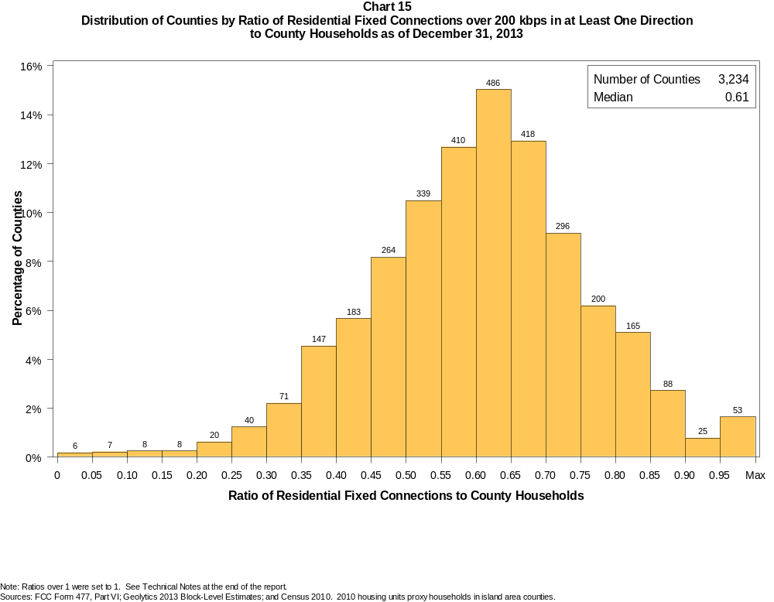

Table 22
Distribution of Counties by Ratio of Residential Fixed Connections over 200 kbps in at Least One Direction
to County Households by Technology as of December 31, 2013

 | Ratio of Residential Fixed Connections to County Households
Technology | Zero | Greater than 0 and no more than 5% | Greater than 5 and no more than 10% | Greater than 10 and no more than 20% | Greater than 20 and no more than 30% | Greater than 30 and no more than 40% | Greater than 40 and no more than 50% | Greater than 50 and no more than 60% | Greater than 60 and no more than 80% | Greater than 80 and no more than 100% | 100% or more
aDSL | 0.6 | 2.8 | 6.3 | 25.8 | 29.3 | 20.7 | 9.0 | 3.7 | 1.3 | 0.3 | 0.1
sDSL | 85.8 | 13.7 | 0.2 | 0.1 | 0.1 | 0.0 | 0.0 | 0.0 | 0.0 | 0.0 | 0.0
Other Wireline | 97.0 | 2.8 | 0.0 | 0.0 | 0.0 | 0.0 | 0.0 | 0.0 | 0.0 | 0.0 | 0.0
Cable Modem | 12.1 | 8.7 | 9.0 | 17.4 | 16.1 | 14.5 | 12.2 | 6.2 | 3.4 | 0.2 | 0.2
FTTP | 50.7 | 32.6 | 5.3 | 4.9 | 2.7 | 1.8 | 1.0 | 0.5 | 0.6 | 0.1 | 0.0
Satellite | 0.6 | 68.9 | 21.8 | 7.9 | 0.7 | 0.1 | 0.0 | 0.0 | 0.0 | 0.0 | 0.0
Fixed Wireless | 37.4 | 47.5 | 8.9 | 5.0 | 0.9 | 0.2 | 0.1 | 0.0 | 0.0 | 0.0 | 0.0
Power Line | 100.0 | 0.0 | 0.0 | 0.0 | 0.0 | 0.0 | 0.0 | 0.0 | 0.0 | 0.0 | 0.0
All Other | 99.9 | 0.0 | 0.0 | 0.0 | 0.0 | 0.0 | 0.0 | 0.0 | 0.0 | 0.0 | 0.0
Total | 0.1 | 0.1 | 0.2 | 0.5 | 1.9 | 6.7 | 13.9 | 23.1 | 43.3 | 9.1 | 1.1

Note: Figures may not sum to totals due to rounding. See Technical Notes at the end of the report.
Sources: FCC Form 477, Part VI; Geolytics 2013 Block-Level Estimates; and Census 2010. 2010 housing units proxy households in island area counties.

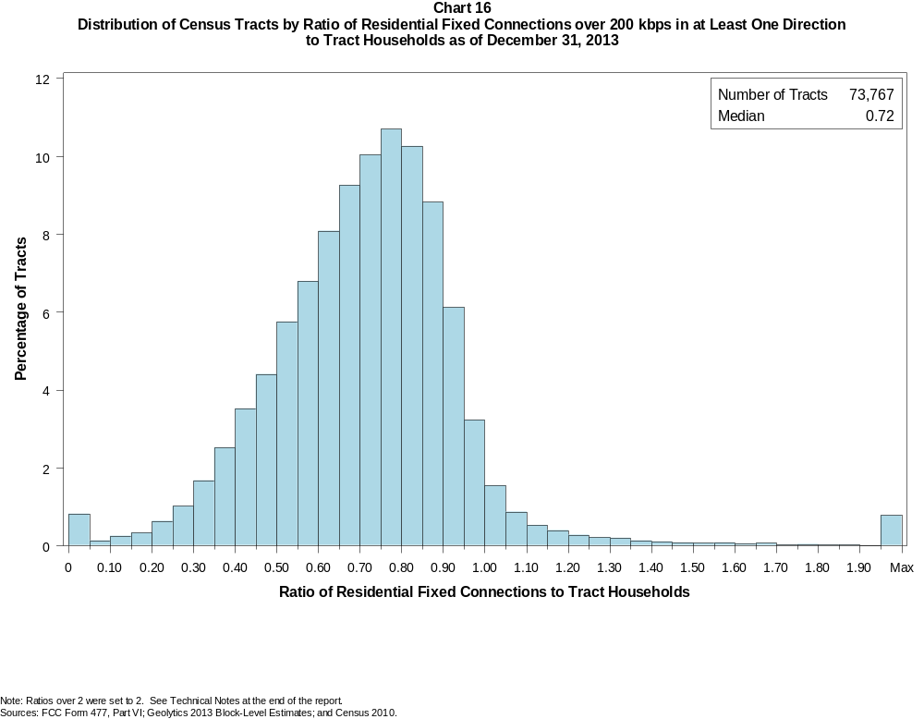

Table 23
Distribution of Census Tracts by Ratio of Residential Fixed Connections over 200 kbps in at Least One Direction
to Tract Households by Technology as of December 31, 2013

 | Ratio of Residential Fixed Connections to Tract Households
Technology | Zero | Greater than 0 and no more than 5% | Greater than 5 and no more than 10% | Greater than 10 and no more than 20% | Greater than 20 and no more than 30% | Greater than 30 and no more than 40% | Greater than 40 and no more than 50% | Greater than 50 and no more than 60% | Greater than 60 and no more than 80% | Greater than 80 and no more than 100% | 100% or more
aDSL | 1.4 | 10.5 | 11.6 | 26.5 | 22.5 | 14.7 | 7.4 | 2.9 | 1.5 | 0.4 | 0.6
sDSL | 97.1 | 2.7 | 0.1 | 0.0 | 0.0 | 0.0 | 0.0 | 0.0 | 0.0 | 0.0 | 0.0
Other Wireline | 99.7 | 0.2 | 0.0 | 0.0 | 0.0 | 0.0 | 0.0 | 0.0 | 0.0 | 0.0 | 0.0
Cable Modem | 5.1 | 3.3 | 2.3 | 6.7 | 13.2 | 18.2 | 18.4 | 15.0 | 14.1 | 2.4 | 1.3
FTTP | 69.6 | 12.4 | 2.2 | 3.0 | 3.0 | 3.7 | 3.2 | 1.8 | 0.9 | 0.1 | 0.1
Satellite | 21.5 | 69.3 | 5.3 | 3.0 | 0.5 | 0.1 | 0.1 | 0.0 | 0.0 | 0.0 | 0.0
Fixed Wireless | 80.8 | 15.0 | 2.0 | 1.5 | 0.4 | 0.2 | 0.1 | 0.0 | 0.0 | 0.0 | 0.0
Power Line | 100.0 | 0.0 | 0.0 | 0.0 | 0.0 | 0.0 | 0.0 | 0.0 | 0.0 | 0.0 | 0.0
All Other | 100.0 | 0.0 | 0.0 | 0.0 | 0.0 | 0.0 | 0.0 | 0.0 | 0.0 | 0.0 | 0.0
Total | 0.7 | 0.1 | 0.1 | 0.6 | 1.7 | 4.2 | 8.0 | 12.5 | 38.1 | 28.5 | 5.6

Note: Figures may not sum to totals due to rounding. See Technical Notes at the end of the report.
Sources: FCC Form 477, Part VI; Geolytics 2013 Block-Level Estimates; and Census 2010.

Table 24
Percentage of Census Tracts with Residential Fixed Connections by Technology as of December 31, 2013
(Connections over 200 kbps in at least one direction)

 | Number of Providers
Technology | Zero | One | Two | Three | Four | Five | Six | Seven or More
aDSL | 1.4 | 56.9 | 31.1 | 9.2 | 1.2 | 0.1 | 0.0 | 0.0
sDSL | 97.1 | 2.8 | 0.1 | 0.0 | 0.0 | 0.0 | 0.0 | 0.0
Other Wireline | 99.7 | 0.3 | 0.0 | 0.0 | 0.0 | 0.0 | 0.0 | 0.0
Cable Modem | 5.1 | 81.6 | 12.7 | 0.5 | 0.0 | 0.0 | 0.0 | 0.0
FTTP | 69.6 | 29.3 | 1.0 | 0.1 | 0.0 | 0.0 | 0.0 | 0.0
Satellite | 21.5 | 24.6 | 52.2 | 1.6 | 0.0 | 0.0 | 0.0 | 0.0
Fixed Wireless | 80.8 | 13.3 | 4.3 | 1.2 | 0.3 | 0.1 | 0.0 | 0.0
Power Line | 100.0 | 0.0 | 0.0 | 0.0 | 0.0 | 0.0 | 0.0 | 0.0
aDSL and/or Cable Modem and/or FTTP | 0.9 | 2.7 | 48.1 | 32.7 | 12.7 | 2.5 | 0.4 | 0.1
Any Technology | 0.7 | 0.4 | 9.4 | 19.4 | 31.8 | 22.2 | 10.1 | 6.1

Note: Figures may not sum to totals due to rounding. The number of providers in a census tract does not necessarily reflect the number of choices available to a particular household, and does not purport
to measure competition.
Sources: FCC Form 477, Part VI and Census 2010.

Table 25
Distribution of Counties by Ratio of Residential Fixed Connections to County Households by State as of December 31, 2013
(Connections over 200 kbps in at least one direction)

 |  | Ratio of Residential Fixed Connections over 200 kbps in at Least One Direction to County Households
State | Counties | Zero | Greater than 0 and no more than 5% | Greater than 5 and no more than 10% | Greater than 10 and no more than 20% | Greater than 20 and no more than 30% | Greater than 30 and no more than 40% | Greater than 40 and no more than 50% | Greater than 50 and no more than 60% | Greater than 60 and no more than 80% | Greater than 80 and no more than 100% | 100% or more
Alabama | 67 | 0 | 0 | 0 | 0 | 3 | 10 | 22 | 17 | 15 | 0 | 0
Alaska | 29 | 0 | 0 | 0 | 0 | 2 | 2 | 6 | 3 | 13 | 2 | 1
American Samoa | 5 | 2 | 1 | 0 | 1 | 0 | 0 | 1 | 0 | 0 | 0 | 0
Arizona | 15 | 0 | 0 | 0 | 0 | 0 | 1 | 1 | 3 | 10 | 0 | 0
Arkansas | 75 | 0 | 0 | 0 | 0 | 4 | 15 | 32 | 15 | 9 | 0 | 0
California | 58 | 0 | 0 | 0 | 0 | 1 | 0 | 2 | 10 | 29 | 15 | 1
Colorado | 64 | 0 | 0 | 0 | 0 | 0 | 1 | 3 | 14 | 26 | 14 | 6
Connecticut | 8 | 0 | 0 | 0 | 0 | 0 | 0 | 0 | 0 | 4 | 4 | 0
Delaware | 3 | 0 | 0 | 0 | 0 | 0 | 0 | 0 | 0 | 1 | 2 | 0
District of Columbia | 1 | 0 | 0 | 0 | 0 | 0 | 0 | 0 | 0 | 1 | 0 | 0
Florida | 67 | 0 | 0 | 0 | 0 | 1 | 2 | 9 | 12 | 24 | 17 | 2
Georgia | 159 | 0 | 0 | 0 | 1 | 9 | 18 | 37 | 37 | 44 | 11 | 2
Guam | 1 | 0 | 0 | 0 | 0 | 0 | 0 | 0 | 0 | 0 | 1 | 0
Hawaii | 5 | 0 | 0 | 0 | 0 | 0 | 0 | 0 | 0 | 2 | 3 | 0
Idaho | 44 | 0 | 0 | 0 | 0 | 0 | 0 | 6 | 12 | 24 | 2 | 0
Illinois | 102 | 0 | 0 | 0 | 1 | 1 | 4 | 11 | 30 | 48 | 4 | 3
Indiana | 92 | 0 | 0 | 0 | 0 | 0 | 0 | 13 | 33 | 43 | 3 | 0
Iowa | 99 | 0 | 0 | 0 | 0 | 0 | 0 | 3 | 24 | 71 | 1 | 0
Kansas | 105 | 0 | 0 | 0 | 0 | 0 | 1 | 7 | 24 | 60 | 13 | 0
Kentucky | 120 | 0 | 0 | 0 | 0 | 3 | 5 | 28 | 32 | 50 | 2 | 0
Louisiana | 64 | 0 | 0 | 0 | 0 | 1 | 11 | 14 | 14 | 22 | 2 | 0
Maine | 16 | 0 | 0 | 0 | 0 | 0 | 0 | 0 | 2 | 11 | 3 | 0
Maryland | 24 | 0 | 0 | 0 | 0 | 0 | 0 | 4 | 1 | 13 | 6 | 0
Massachusetts | 14 | 0 | 0 | 0 | 0 | 0 | 0 | 0 | 0 | 7 | 4 | 3
Michigan | 83 | 0 | 0 | 0 | 0 | 0 | 4 | 5 | 27 | 44 | 3 | 0
Minnesota | 87 | 0 | 0 | 0 | 0 | 0 | 1 | 2 | 13 | 68 | 3 | 0
Mississippi | 82 | 0 | 0 | 0 | 0 | 14 | 31 | 19 | 11 | 7 | 0 | 0
Missouri | 115 | 0 | 0 | 0 | 1 | 2 | 9 | 26 | 41 | 33 | 3 | 0
Montana | 56 | 0 | 0 | 0 | 0 | 1 | 1 | 6 | 7 | 37 | 4 | 0
Nebraska | 93 | 0 | 0 | 0 | 0 | 0 | 4 | 5 | 25 | 57 | 2 | 0

Table 25 - Continued
Distribution of Counties by Ratio of Residential Fixed Connections to County Households by State as of December 31, 2013
(Connections over 200 kbps in at least one direction)

 |  | Ratio of Residential Fixed Connections over 200 kbps in at Least One Direction to County Households
State | Counties | Zero | Greater than 0 and no more than 5% | Greater than 5 and no more than 10% | Greater than 10 and no more than 20% | Greater than 20 and no more than 30% | Greater than 30 and no more than 40% | Greater than 40 and no more than 50% | Greater than 50 and no more than 60% | Greater than 60 and no more than 80% | Greater than 80 and no more than 100% | 100% or more
Nevada | 17 | 0 | 0 | 0 | 0 | 0 | 2 | 5 | 3 | 7 | 0 | 0
New Hampshire | 10 | 0 | 0 | 0 | 0 | 0 | 0 | 0 | 0 | 4 | 5 | 1
New Jersey | 21 | 0 | 0 | 0 | 0 | 0 | 0 | 0 | 0 | 6 | 14 | 1
New Mexico | 33 | 0 | 0 | 0 | 0 | 0 | 5 | 4 | 12 | 10 | 2 | 0
New York | 62 | 0 | 0 | 0 | 0 | 0 | 0 | 0 | 2 | 41 | 18 | 1
North Carolina | 100 | 0 | 0 | 0 | 0 | 0 | 2 | 19 | 24 | 41 | 13 | 1
North Dakota | 53 | 0 | 0 | 0 | 0 | 0 | 0 | 3 | 6 | 31 | 12 | 1
Northern Mariana Isl | 4 | 1 | 0 | 0 | 1 | 1 | 0 | 0 | 1 | 0 | 0 | 0
Ohio | 88 | 0 | 0 | 0 | 0 | 0 | 1 | 3 | 22 | 54 | 8 | 0
Oklahoma | 77 | 0 | 0 | 0 | 0 | 1 | 12 | 24 | 21 | 16 | 3 | 0
Oregon | 36 | 0 | 0 | 0 | 0 | 0 | 0 | 1 | 10 | 21 | 4 | 0
Pennsylvania | 67 | 0 | 0 | 0 | 0 | 0 | 1 | 1 | 10 | 41 | 13 | 1
Puerto Rico | 78 | 0 | 2 | 7 | 9 | 5 | 13 | 7 | 7 | 9 | 11 | 8
Rhode Island | 5 | 0 | 0 | 0 | 0 | 0 | 0 | 0 | 0 | 3 | 2 | 0
South Carolina | 46 | 0 | 0 | 0 | 0 | 0 | 7 | 8 | 13 | 13 | 5 | 0
South Dakota | 66 | 0 | 0 | 0 | 0 | 0 | 2 | 3 | 8 | 47 | 6 | 0
Tennessee | 95 | 0 | 0 | 0 | 1 | 0 | 7 | 30 | 37 | 19 | 1 | 0
Texas | 254 | 0 | 0 | 0 | 0 | 2 | 27 | 51 | 79 | 80 | 12 | 3
Utah | 29 | 0 | 0 | 0 | 0 | 1 | 1 | 1 | 4 | 15 | 6 | 1
Vermont | 14 | 0 | 0 | 0 | 0 | 0 | 0 | 0 | 0 | 7 | 7 | 0
Virgin Islands | 3 | 0 | 0 | 0 | 0 | 1 | 0 | 0 | 1 | 1 | 0 | 0
Virginia | 134 | 0 | 0 | 0 | 1 | 8 | 14 | 16 | 37 | 41 | 17 | 0
Washington | 39 | 0 | 0 | 0 | 0 | 0 | 1 | 1 | 7 | 24 | 6 | 0
West Virginia | 55 | 0 | 0 | 0 | 0 | 0 | 2 | 7 | 19 | 26 | 1 | 0
Wisconsin | 72 | 0 | 0 | 0 | 0 | 0 | 0 | 1 | 10 | 57 | 4 | 0
Wyoming | 23 | 0 | 0 | 0 | 0 | 0 | 0 | 2 | 7 | 13 | 1 | 0
Total | 3,234 | 3 | 3 | 7 | 16 | 61 | 217 | 449 | 747 | 1400 | 295 | 36

Note: Figures may not sum to totals due to rounding. See Technical Notes at the end of the report.
Sources: FCC Form 477, Part VI (Connections); Geolytics 2013 Block-Level Estimates (Households for U.S. and District of Columbia); Census 2010 (Housing units for Puerto Rico, American Samoa,
Guam, Northern Mariana Islands and U.S. Virgin Islands).

Table 26
Distribution of Census Tracts by Ratio of Residential Fixed Connections to Tract Households by State as of December 31, 2013
(Connections over 200 kbps in at least one direction)

 |  | Ratio of Residential Fixed Connections over 200 kbps in at Least One Direction to Tract Households
State | Tracts | Zero | Greater than 0 and no more than 5% | Greater than 5 and no more than 10% | Greater than 10 and no more than 20% | Greater than 20 and no more than 30% | Greater than 30 and no more than 40% | Greater than 40 and no more than 50% | Greater than 50 and no more than 60% | Greater than 60 and no more than 80% | Greater than 80 and no more than 100% | 100% or more
Alabama | 1,179 | 5 | 1 | 2 | 4 | 60 | 138 | 252 | 234 | 354 | 107 | 22
Alaska | 167 | 1 | 0 | 1 | 2 | 5 | 8 | 11 | 20 | 77 | 28 | 14
American Samoa | 18 | 3 | 6 | 1 | 0 | 2 | 1 | 1 | 0 | 2 | 0 | 2
Arizona | 1,526 | 18 | 7 | 9 | 19 | 18 | 48 | 101 | 203 | 532 | 463 | 108
Arkansas | 686 | 2 | 0 | 3 | 24 | 64 | 114 | 139 | 113 | 153 | 53 | 21
California | 8,036 | 49 | 7 | 7 | 33 | 63 | 137 | 360 | 648 | 2,862 | 3,492 | 378
Colorado | 1,249 | 13 | 0 | 2 | 0 | 3 | 12 | 41 | 99 | 514 | 473 | 92
Connecticut | 829 | 3 | 0 | 0 | 0 | 2 | 13 | 29 | 55 | 275 | 425 | 27
Delaware | 215 | 1 | 0 | 0 | 0 | 1 | 0 | 8 | 25 | 70 | 90 | 20
District of Columbia | 179 | 1 | 0 | 0 | 0 | 0 | 2 | 14 | 30 | 78 | 44 | 10
Florida | 4,199 | 38 | 2 | 0 | 2 | 21 | 90 | 206 | 406 | 1,605 | 1,465 | 364
Georgia | 1,964 | 11 | 1 | 2 | 16 | 51 | 152 | 238 | 327 | 716 | 386 | 64
Guam | 56 | 4 | 1 | 3 | 3 | 2 | 8 | 4 | 1 | 2 | 2 | 26
Hawaii | 326 | 11 | 0 | 1 | 2 | 1 | 0 | 3 | 19 | 131 | 105 | 53
Idaho | 298 | 1 | 0 | 0 | 2 | 2 | 9 | 16 | 53 | 170 | 38 | 7
Illinois | 3,121 | 7 | 2 | 3 | 9 | 34 | 127 | 299 | 464 | 1,339 | 766 | 71
Indiana | 1,508 | 5 | 2 | 0 | 4 | 13 | 36 | 180 | 346 | 684 | 218 | 20
Iowa | 825 | 2 | 1 | 1 | 0 | 2 | 10 | 47 | 161 | 508 | 83 | 10
Kansas | 770 | 9 | 0 | 0 | 4 | 7 | 31 | 67 | 145 | 331 | 135 | 41
Kentucky | 1,115 | 11 | 1 | 2 | 7 | 23 | 67 | 141 | 240 | 443 | 154 | 26
Louisiana | 1,136 | 14 | 1 | 0 | 4 | 22 | 97 | 183 | 227 | 423 | 140 | 25
Maine | 351 | 0 | 0 | 0 | 0 | 2 | 5 | 13 | 35 | 175 | 93 | 28
Maryland | 1,394 | 8 | 0 | 0 | 2 | 8 | 59 | 88 | 108 | 455 | 585 | 81
Massachusetts | 1,471 | 12 | 1 | 1 | 0 | 1 | 7 | 19 | 78 | 494 | 772 | 86
Michigan | 2,767 | 30 | 0 | 3 | 14 | 46 | 197 | 258 | 392 | 1,077 | 712 | 38
Minnesota | 1,335 | 4 | 2 | 0 | 3 | 6 | 16 | 56 | 174 | 705 | 352 | 17
Mississippi | 661 | 4 | 0 | 1 | 11 | 69 | 155 | 137 | 111 | 127 | 37 | 9
Missouri | 1,393 | 6 | 0 | 2 | 11 | 48 | 116 | 177 | 269 | 485 | 242 | 37
Montana | 271 | 2 | 0 | 2 | 4 | 3 | 4 | 17 | 56 | 136 | 34 | 13
Nebraska | 532 | 2 | 0 | 0 | 0 | 0 | 11 | 38 | 85 | 263 | 114 | 19

Table 26 - Continued
Distribution of Census Tracts by Ratio of Residential Fixed Connections to Tract Households by State as of December 31, 2013
(Connections over 200 kbps in at least one direction)

 |  | Ratio of Residential Fixed Connections over 200 kbps in at Least One Direction to Tract Households
State | Tracts | Zero | Greater than 0 and no more than 5% | Greater than 5 and no more than 10% | Greater than 10 and no more than 20% | Greater than 20 and no more than 30% | Greater than 30 and no more than 40% | Greater than 40 and no more than 50% | Greater than 50 and no more than 60% | Greater than 60 and no more than 80% | Greater than 80 and no more than 100% | 100% or more
Nevada | 683 | 6 | 0 | 0 | 7 | 13 | 21 | 65 | 84 | 296 | 152 | 39
New Hampshire | 294 | 2 | 0 | 0 | 1 | 0 | 0 | 1 | 6 | 95 | 174 | 15
New Jersey | 2,004 | 9 | 1 | 0 | 1 | 0 | 4 | 18 | 65 | 667 | 1,087 | 152
New Mexico | 499 | 4 | 9 | 7 | 6 | 12 | 39 | 77 | 92 | 185 | 54 | 14
New York | 4,900 | 69 | 1 | 1 | 18 | 16 | 44 | 115 | 274 | 1,981 | 1,999 | 382
North Carolina | 2,183 | 19 | 1 | 0 | 6 | 34 | 93 | 243 | 380 | 764 | 404 | 239
North Dakota | 205 | 0 | 0 | 0 | 0 | 0 | 5 | 8 | 29 | 100 | 47 | 16
Northern Mariana Isl | 22 | 2 | 0 | 0 | 2 | 4 | 3 | 2 | 2 | 4 | 1 | 2
Ohio | 2,946 | 7 | 0 | 0 | 7 | 27 | 118 | 247 | 410 | 1,248 | 743 | 139
Oklahoma | 1,046 | 2 | 3 | 6 | 17 | 53 | 113 | 166 | 197 | 301 | 144 | 44
Oregon | 827 | 2 | 0 | 0 | 1 | 1 | 6 | 20 | 95 | 476 | 208 | 18
Pennsylvania | 3,217 | 19 | 1 | 2 | 19 | 31 | 46 | 146 | 395 | 1,445 | 937 | 176
Puerto Rico | 903 | 1 | 21 | 24 | 65 | 73 | 47 | 55 | 56 | 106 | 75 | 380
Rhode Island | 241 | 1 | 0 | 0 | 1 | 0 | 0 | 1 | 10 | 129 | 94 | 5
South Carolina | 1,097 | 11 | 0 | 1 | 5 | 32 | 89 | 151 | 191 | 350 | 172 | 95
South Dakota | 222 | 0 | 1 | 0 | 0 | 1 | 8 | 6 | 37 | 127 | 36 | 6
Tennessee | 1,497 | 20 | 2 | 0 | 7 | 52 | 131 | 278 | 315 | 474 | 187 | 31
Texas | 5,253 | 40 | 2 | 9 | 51 | 186 | 472 | 772 | 756 | 1,591 | 1,016 | 358
Utah | 588 | 4 | 1 | 4 | 1 | 1 | 4 | 12 | 52 | 266 | 203 | 40
Vermont | 184 | 1 | 0 | 0 | 0 | 0 | 1 | 0 | 8 | 91 | 65 | 18
Virgin Islands | 29 | 0 | 0 | 1 | 2 | 3 | 2 | 2 | 2 | 5 | 4 | 8
Virginia | 1,895 | 22 | 0 | 0 | 13 | 65 | 95 | 148 | 232 | 522 | 676 | 122
Washington | 1,446 | 2 | 0 | 2 | 4 | 14 | 18 | 45 | 104 | 669 | 561 | 27
West Virginia | 484 | 0 | 1 | 2 | 11 | 16 | 32 | 44 | 93 | 197 | 65 | 23
Wisconsin | 1,393 | 3 | 2 | 0 | 4 | 5 | 47 | 95 | 201 | 748 | 266 | 22
Wyoming | 132 | 1 | 0 | 0 | 0 | 4 | 2 | 9 | 23 | 67 | 24 | 2
Total | 73,767 | 524 | 81 | 105 | 429 | 1,222 | 3,110 | 5,869 | 9,233 | 28,090 | 21,002 | 4,102

Note: Figures may not sum to totals due to rounding. See Technical Notes at the end of the report.
Sources: FCC Form 477, Part VI (Connections); Geolytics 2013 Block-Level Estimates (Households for U.S. and District of Columbia); Census 2010 (Households for Puerto Rico, American Samoa,
Guam, Northern Mariana Islands and U.S. Virgin Islands).

